Intro

Team: Blood

# Members: Darcy Ayers, Michaela Harris, Jason Hoffman, and Hannah Kragt

# Date: 12/03/2024

# 

# Table of Contents

## WA2: Interview

### 2.1 Interview research plan

### 2.2 Practice interview

### 2.3 Interview and debrief

### 2.4 Thank you follow up

## WA3: Community context, needs statement, and design criteria

### 3.1 Community context

### 3.2 Needs Statement

### 3.3 Design criteria

## WA4: Design solutions

### 4.1 Existing solutions

### 4.2 Brainstorming

### 4.3 Trade study

### 4.4 Preliminary design solutions

### 4.5 Design progress

## WA5: Testing plan and prototype update

### 5.1 Testing

#### 5.1.1 Summary of testing procedures

#### 5.1.2 Details of testing procedure

### 5.2 Prototyping

#### 5.2.1 Prototype update

#### 5.2.2 Prototype context

**WA6: Testing report, iteration plan based on partner feedback**

6.1 Validation Tests

6.2 Verification Tests

6.3 Prototype Update

**WA7: Training, handoff, continuation plan for partners**

7.1 Handoff Documents

7.2 Justification

## Appendix

### WA1: Description, Skills, Objectives

Calculations

## Resources

WA2

## Written Assignment 2: Interview

### **2.1 Interview research plan**

1. **Who will you be interviewing?**

* Dr. Anne Alaniz and/or Dr. Jonie Hope

1. **What are your specific goals for the interview and what do you hope to learn from it?**

* Learn about Anne’s background and Pothawira International as a whole
* Ask about the new OR, Blood bank, and overall context of where this device will be implemented
* Context on what they have right now as a solution and the biggest limitations with this solution (blood-giving sets)
* Learn about what a successful device would look like
* Discuss the project timeline & Anne’s overall availability throughout the semester

1. **What will you say to your participant to introduce the project/research goals? (Write 3-4 sentences, and be sure to ask permission to record audio)**

First, we will introduce ourselves and our team, and review the class's overall premise and understanding of the blood-giving sets and rewarming device. We will then ask for permission to record the audio or video. We would then express that we are calling to learn more about the current needs of the clinic and to get a better understanding of what this project will look like through their eyes. Next, we will transition to the basic design criteria we had in mind for the devices and ask for her input.

1. **What questions will you be asking your participant (10-15 questions)? For each question please write both the goal of the question (1-2 sentences) and any probing questions/topics you may use to get more information from your subject. By probing questions, we mean any questions that will help your interviewee understand your main question better. While we understand the actual interview may not follow this script exactly, we want to get a good sense of what you may be asking your participant to share. Questions should be ranked in order of importance for time allowances (30 points)**

**All Interview notes for Mock & Real:**

[**Interview Notes**](https://docs.google.com/document/d/1gfVj_sT0WZNHvcMYFkR1uiB6jIyV4EIgsOkbemMGZ28/edit?usp=sharing)

[**9-11 Anne Joanie Interview.m4a**](https://drive.google.com/file/d/1iS_hcUGHU7Z_0s0W7iTi-xGKjND5DaCC/view?usp=sharing)

* **Question: Can you tell us about your background?**  
  Goal: We hope to gain background and context for our project and how Dr. Anne is involved.
* **Question: Can you tell us about the founding of Pothawira and the current setting?**  
  Goal: We want to learn about the location/community in which our device is being presented.
* **Question: What is your vision for how the implementation of the blood bank will help the clinic and the population of Salima?**  
  Goal: Understand the larger picture of what the blood bank (and the new devices that will come with it) is trying to accomplish within the hospital and OR’s grand scheme.
* **Question: How does the government help/hurt running a successful medical facility?**  
  Goal: Understand how government regulations and spending affect their ability to run a medical facility
* **Question: What component of the blood-giving sets would you say is the limiting factor?**  
  Goal: Find out which components of the blood-giving sets are most crucial to be reusable.
* **Question: How much blood do you intend/expect to be stored at the same time, and how many blood donations do you expect to receive in a day?**  
  Goal: Get a gauge on how many of these sets they will need.
* **Question: What do you use to sterilize your equipment currently, and/or if that will change in the future? What do you expect the new OR will have in terms of sterilization?**   
  Goal: Learn about the sterilization process used to understand how our design will be sterilized and what we need to prepare them for.
* **Question: We want whatever we make to be reproducible. Do you know what tools/technologies the engineering students at the Malawi Polytechnic Institute have at their disposal?**  
  Goal: While we may only be able to make one or a few of these sets/ warmers, we want to be able to pass on this project to biomedical engineering students at the local university. Anne has already expressed that she could connect us with them.
* **Question: How do you anticipate the infection rate of HIV/AIDS and other current health trends in Malawi affecting this project?**  
  Goal: Understand current health trends in Malawi and how to account for them in the planning of our project if necessary.
* **(SKIP) Question: What would you say is the comfort level of the clinicians in Pothawira with assembling or disassembling devices? For example, changing batteries, screwing pieces together/apart, using hand tools to assemble/disassemble devices, etc.**

Goal: Understand how stand-alone our device needs to be and how well the clinicians could work on the device in the clinic.

* **Question: What are some ideas you had for what the final device would look like/ how it will function?**

Goal: Get a gauge of what they are expecting from the device and help us a little with our design specifications.

* **Question: How have the solar power panels donated by Japan changed the adversities faced by inconsistent electricity? Given this context, Ideally, would the product work independently of the electricity (generator), or has this grid been enough to support such that our product could rely on wall powers?**   
  Goal: Understand how the utilities have been affected by this donation and what context may be important for power sources.

1. **How long do you anticipate the interview will take?**

We anticipate that this interview will take 45 minutes to an hour.

### **2.2 Practice interview**

1. **Were your questions clear to the interviewee?**
   1. Yes. We interviewed Nancy Kragt who has an extensive background in this area as she has been involved in Pothawira (Safe Haven) Christian Mission Organisation for over 25+ years.
2. **Did you balance who asked each question?**
   1. Yes, we each took turns asking the questions.
3. **Did you find the notes taken during the interview to be sufficient to recall the information gathered?**
   1. Yes, Michaela took notes on a separate document during the interview and we also recorded it using the voice memo app.
4. **What are 3 things you will keep in mind for the real interview?**
   1. We will consider the pacing and order of our questions to make sure that the interview flows in a timely manner.
   2. We will adjust some of our questions to be more clear and also track any follow up questions we have to thoroughly probe for the information we need.
   3. We need to give more information on the basis of our project and what our goals are before hopping into questions.

### **2.3 Interview and Debrief**

1. **Did your interview accomplish its goals? Why or why not? (4-5 sentences)**

Yes, we had a 45-minute meeting with Dr. Anne and Joanie, which was very productive in getting answers not only to our questions but also to background knowledge about the clinic and Malawai. While we were not able to ask all of the questions we planned to ask, we felt the in-depth answers and conversations we had were very productive. It was especially helpful to have two perspectives from both of them on the call. This was a great first time for the team to meet and for Dr. Anne and Joanie to understand the scope and goal of our project this semester.

1. **How did the participant seem to feel? Was the participant confused, frustrated, or lost at any point? (3-4 sentences)**

The participants both seemed very excited about the project. They were both engaged throughout the interview answering questions and providing context to the problem. Joanie shared a slide deck about the plan and progress for the surgical center. It was great to see the progress and where our project would be implemented within the space.

1. **Did you make any changes to your questions based on this practice interview? How did that change your interview?**

We did not make any changes to our interview based on the practice. We did move a few questions to lower priority when our meeting time got shifted due to Dr. Anne being in a case.

1. **What answer was most surprising or would have otherwise been hard to understand or learn about without the interview?**

Learning about the setup of the clinic such as the materials and tools that they will have available was a really important piece of the interview. They described how the blood bank would be set up, how much blood they would be pumping daily, the sterilization process that they would have in place, and what the current practices are that make this such a large issue. This will inform a lot of our decisions and design. It was important to have this meeting before ranking the importance of certain criteria so we could make better-informed decisions.

### **2.4 Thank you follow up**

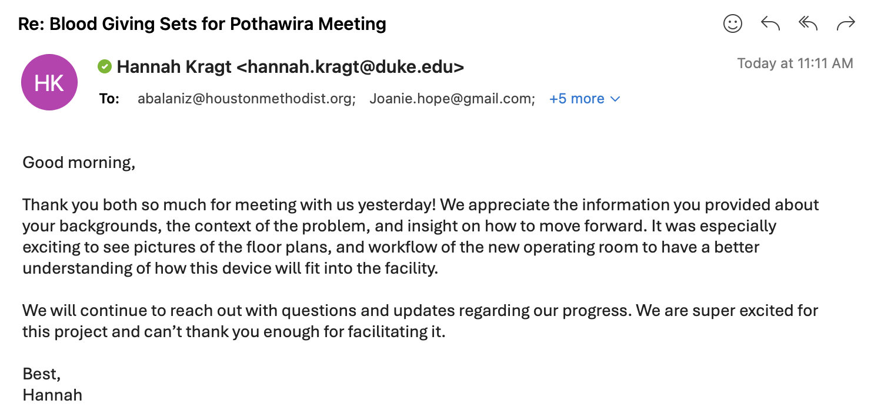

WA3

## Written Assignment 3: Community Context, Needs Statement & Design Criteria

### **3.1 Community Context**

**Location and Geography**

Salima is a town in the Central Region of Malawi, located approximately 110 km east of Lilongwe, the capital city. It lies near Lake Malawi and serves as an important trading center and tourist destination (2). The town is connected via the M5 Lakeshore Road, making it accessible by car in about 1.5 hours from Lilongwe​. In terms of healthcare, Salima District Hospital serves as a regional facility. Most residents use bicycles or walk to nearby healthcare facilities. The Salima District Hospital is a referral facility for smaller rural hospitals. Travel to the hospital from rural areas is often difficult due to poor transportation infrastructure. Salima District Hospital can be accessed by car from Lilongwe in approximately 1.5 hours ​(1).

**Population and Language**

The population of Salima District is around 478,346, with a majority of 72.9% Chewa people. Other significant groups include the Yao (19%), Ngoni (2.9%), and Lomwe (2%). The most widely spoken language in Salima is Chichewa, used by most of the population in daily communication (3).

**Historical Significance and Healthcare**

Malawi's healthcare system has been shaped by key historical events from colonial times to the present. Under British rule (1891-1964), healthcare focused on Europeans, with missionaries providing limited services to locals. This left a legacy of rural, faith-based healthcare facilities that still play a significant role in the country’s healthcare system today. These facilities, while beneficial, are often under-resourced and geographically isolated, translating to minimal access to quality healthcare for most Malawians, especially in rural areas.

After independence in 1964, Dr. Hastings Banda’s government centralized healthcare but underfunded it, focusing more on agriculture. The Ministry of Health was established, but access to quality care remained uneven, especially in rural areas (4,5). Healthcare access was limited by the availability of trained staff, medical supplies, and infrastructure, with many rural clinics unable to meet the population’s needs.

The transition to democracy in 1994 marked a shift, with the government introducing free healthcare services. This move was intended to expand access to care but strained an already underfunded system. International donors, including the World Health Organization (WHO) and various non-governmental organizations (NGOs), stepped in to fund critical healthcare initiatives. However, many of the programs—focused on HIV/AIDS, malaria, and maternal health—were driven by the priorities of donor organizations rather than Malawi's internal healthcare policies. While the government collaborated with donors, Malawi became heavily reliant on external aid, which directed much of the decision-making in these key areas (6).

The HIV/AIDS epidemic of the 1980s and 1990s had a profound impact, prompting major global health initiatives and increased investment in Malawi’s healthcare infrastructure. The epidemic drastically increased the demand for medical care, particularly for antiretroviral therapy (ART) and HIV-related services. It led to the loss of many healthcare workers due to infection, exacerbating an already critical shortage of trained personnel. International funding, including from PEPFAR and the Global Fund, improved HIV treatment and care, bringing relief through medical supplies and training for healthcare workers. However, these initiatives also deepened the country's dependency on foreign aid, as the healthcare system became aligned with donor-driven priorities (6,7).

In recent years, Malawi has made progress in improving maternal and child health, reducing malaria deaths, and expanding access to basic healthcare, though it still faces challenges like resource constraints and a shortage of healthcare workers (7).

**Government Structure**

Malawi's healthcare system is primarily governed by the Ministry of Health, which operates under the executive branch of the government. The Ministry is responsible for developing and implementing national health policies, managing public health services, and coordinating with international donors. Key responsibilities include hospital administration, healthcare worker staffing, and national health campaigns for issues like HIV/AIDS, malaria, and maternal health (8,9).

At the local level, Malawi’s 28 districts have local councils responsible for delivering healthcare services, including the management of district hospitals and clinics. These councils work under the Ministry’s direction but focus on the specific healthcare needs of their communities, promoting decentralization while maintaining central oversight (10).

The legislative branch, through the National Assembly, plays a critical role in passing health-related laws and approving the national healthcare budget, ensuring that the Ministry of Health receives adequate funding for national health priorities (11).

**Recent Events and Impact on the Project**

Malawi is currently experiencing a drought that has exacerbated food insecurity (16). It is projected that 5.7 million people in the country will face acute food shortages between October 2024 and March 2025 (15). This situation may directly impact the implementation of healthcare-related projects, including those in Salima, as the country grapples with the dual burdens of hunger and limited resources for healthcare delivery.

**Health Trends Relevant to the Project**

Health trends in Malawi, particularly in Salima, are closely linked to the high burden of infectious diseases and resource limitations. There is a significant unmet need for family planning services, and the country continues to face a high incidence of HIV, with nearly one million people living with the virus. The leading cause of death in the region is AIDS/HIV (12). In cases where bone marrow has been compromised, blood transfusions for patients may be necessary, which would require the use of our device. Particularly because AIDS/HIV is a bloodborne pathogen, the device would need to be sterilized as well as possible to prevent any further spread of the disease.

Malnutrition remains a critical issue, with 37% of children suffering from chronic malnutrition (19). Malawi is also heavily burdened by malaria, with an incidence rate of 332 cases per 1,000 people annually, resulting in approximately 4.8 million episodes each year (19). Malaria infects red blood cells in a patient, necessitating transfusions in severe cases to flush the disease out and prevent the patient from experiencing a lethal level of blood loss (21). Given how widespread this disease is, it is evident that the Pothawira clinic will be dealing with many cases of malaria. In order to assist these people, having our blood bags will be necessary for the transfusions.

The healthcare sector is further strained by a shortage of qualified healthcare workers, with over a third of established positions remaining unfilled (21). Thus, having a blood bag that is easy to use will be critical for transfusion efficacy while also allowing for many patients to be treated.

Additionally, maternal and child health outcomes place tremendous strain on the healthcare system, creating a pressing need for improved healthcare services and infrastructure in areas like Salima. In our interview, we were informed that 29% of pregnancies in Malawi happen during adolescence. Furthermore, Dr. Anne said that many individuals suffer from postpartum hemorrhaging, which requires an immense amount of blood to keep the patient alive. We were told a story of how a woman walked 50 miles to the clinic to try to save her baby only to pass away from postpartum hemorrhaging because there were no giving sets available for her to receive the necessary transfusion. To prevent loss of life from a lack of transfusion supplies, the reusability of our device is critically important.

**Barriers Necessitating the Project**

The current setup in the clinic in Salima lacks any sort of formal blood transfusion mechanism to bring blood to a patient. During our interview, Dr. Anne and Dr. Joanie both described how patients who are coming in for surgery need to have a relative with the same blood type on standby to donate blood. At the clinic, the donor’s blood is tested and put into a bag. If there are bags available, the issue then is that there are no “giving sets” – or mechanisms to connect the blood to the patient. The nearest location with giving sets is the capital, which is 2 hours away. Even when families rush there and back, both doctors described many instances where patients have died because they could not get blood in time. This is a particularly common occurrence in women who have postpartum hemorrhaging, those with sickle cell who need a transfusion, and children with malaria (Interview). Thus a mechanism that is sterilizable and reusable to hold the bag and connect it to the patient is necessary to increase their chances of survival.

The clinic is currently under construction and is set to be equipped with a blood bank that will store the blood, but they still need a way to transfer, heat, and sterilize it. Blood needs to be reheated to reenter the body, which is a relatively new problem as the fridge-held blood bank supply didn't used to exist.

**Quality of Utilities**

Utilities in Malawi, including electricity, gas, and water, are notoriously unreliable. Power outages are frequent, with Malawian firms experiencing an average of 7.4 outages per month, each lasting around 3.6 hours (13). The state-run electricity provider, ESCOM, has been criticized for poor corporate governance and financial management, which have contributed to the country's energy crisis (13). Only 15% of Malawi’s population has access to electricity, most of which comes from hydro-powered grids, with a smaller percentage relying on solar energy (17). Salima District Hospital has benefited from the donation of a high-powered solar system from the People’s Republic of Japan, which has helped to alleviate some of the power challenges the hospital faces (18). However, power outages still result in the loss of medical supplies, as drugs that require refrigeration often spoil due to a lack of reliable cooling facilities (17).

### **3.2 Needs Statement**

The current method for blood transfusions at the Pothawira Surgical Center in Salima, Malawi, relies on on-site blood gathering, testing, and donation from a patient’s family member with the same blood type. The clinic lacks the ability to store blood donations and frequently runs out of necessary equipment for blood transfusions, leading to critical delays in patient care. The local population, which includes over 800,000 residents, is in urgent need of reliable and efficient transfusion methods. There is a need for affordable, reusable, and sterilizable blood-giving sets and a blood-warming device that can safely warm stored blood to the optimal transfusion temperature. These devices must be durable, compatible with existing equipment, and made from locally available materials to ensure sustainability, improving patient outcomes, and meeting the operational demands of the new blood bank and surgical center opening in 2025.

### **3.3 Design criteria**

1. **Sterilizable (Must Have)**

*Justification*: The blood-giving sets must be made with components that can withstand sterilization procedures used at the clinic (e.g., high-temperature cleaning). The blood-warming device must also be sterilizable to maintain safety in blood handling and administration.

*Verification*: We will test the device's components by subjecting them to multiple cycles of sterilization (e.g., autoclaving at 121°C for 30 minutes) and evaluating their structural integrity, material degradation, and cleanliness. Each component will undergo at least 50 sterilization cycles to verify long-term usability without degradation (21).

1. **Maintain blood at a target temperature of 36°C ± 4°C for 10-15 minutes (Must Have)**

*Justification*: The blood-warming device must warm stored blood to a safe body temperature before transfusion, preventing hypothermia in patients. The ability to hold the blood at the target temperature for a sufficient period ensures it is ready for use when needed.

*Verification*: The warming device will be tested by measuring the temperature of saline samples (using a calibrated thermometer)being emitted from the warming device over a 5-minute period. This will confirm that the temperature consistently stays within the 36°C ± 4°C range. Testing will include different ambient conditions to simulate real-world use (20).

1. **Locally available resources (Must Have)**

*Justification*: The device should be made from materials that are available or easily accessible in Malawi to ensure long-term sustainability and reproducibility. This will reduce dependency on external suppliers and allow local healthcare providers to maintain and replicate the device.

*Verification*: A conversation will be conducted with local suppliers and healthcare providers in Malawi to confirm the availability of materials needed to manufacture the devices.

1. **Cost under $100 for blood-giving sets and under $300 for the warming device (Nice to Have)***Justification*: The cost of the devices must meet the budgetary constraints of the clinic and the Malawian healthcare system. These numbers are safe upper limits for cost, given by our sponsor. The affordability will ensure that the devices can be widely used and sustained in the resource-limited setting.

*Verification*: A cost analysis will be conducted by sourcing material quotes from local and international suppliers, along with labor costs. We will ensure the final production cost remains within the specified range.

1. **Air-tight seal (Must Have)***Justification*: The blood-giving sets must maintain an air-tight seal to prevent contamination and ensure the safe transfer of blood. This is essential to avoid infection risks and maintain the integrity of blood during transfusion.

*Verification*: We will test the air-tightness by applying water or air pressure to the system and ensuring no leaks occur under typical use conditions. The system will also be tested under vacuum conditions to simulate blood flow during transfusion.

1. **Reusable, Durability to withstand 200 uses (Must Have)***Justification*: The blood-giving sets must be reusable and durable enough to withstand multiple sterilization cycles and uses without degrading. This will ensure that the investment in each set maximizes its long-term use and reduces the need for frequent replacements.

*Verification*: The devices will undergo mechanical fatigue testing by simulating repeated use, including sterilization cycles, disassembly, and reassembly.

1. **Portability and easy-to-use design (Nice to Have)***Justification*: The device should be portable and easy to use by healthcare workers with minimal training. This will facilitate use in various settings within the clinic and ensure the device can be employed efficiently during emergency situations.

*Verification*: The device’s portability will be verified by ensuring it weighs less than 2 kg and can be easily transported by a single healthcare worker between rooms (). Ease of use will be validated through usability tests where healthcare workers will be able to set up the device within 10 minutes and operate it effectively after no more than 30 minutes of training ().

1. **Energy-efficient (Nice to Have)***Justification*: Given the inconsistent electricity supply in Malawi, the blood-warming device should ideally be energy-efficient (devices consuming less than 50W are considered energy-efficient in low-resource clinics) () or capable of functioning with alternative power sources such as solar energy. This will ensure continuous operation even in areas with unreliable electricity.

*Verification*: We will measure the power consumption of the warming device using a power meter, ensuring it consumes less than 50W in typical operating conditions. Tests will include scenarios of both continuous and intermittent use.

1. **Mechanical robustness and resistance to mechanical stress (Must Have)***Justification*: The devices must be able to withstand rough handling, transport, and drops in a busy clinic environment without breaking or malfunctioning. According to *WHO* standards, medical devices in resource-limited settings must be rugged and able to withstand rough handling, transport, and frequent use. This ensures longevity and reduces the cost of repairs or replacements.

*Verification*: The devices will be subjected to mechanical stress tests, including drop tests from 1 meter and impact resistance tests. Components will also be tested for fatigue by applying repeated pressure and strain ().

1. **Compact design for storage (Nice to Have)**

*Justification*: The blood storage device must be of comparable shape and size to existing blood bags to fit seamlessly into the current blood storage infrastructure at the clinic. This ensures compatibility with existing refrigeration and storage systems, reducing the need for modifications or additional storage solutions.

*Verification*: We will compare the dimensions of the blood storage device to standard blood bags (approximately 10-15 cm in width and 20-25 cm in length) and test its fit in clinical storage units. The device must occupy the same space as a typical blood bag in refrigerators and storage racks used at the clinic, ensuring it integrates smoothly with the current setup.

1. **Community Comfortability (Nice to Have)**

*Justification*: The blood-giving set must be as non-intimidating as the current disposable sets to ensure patient comfort and acceptance, supporting a smooth transition and consistent use.

*Verification*: Surveys will compare patient comfort levels using a Likert scale, assessing the new set against existing disposable sets. Usability tests will gauge willingness and preference through direct comparison feedback.

WA4

## Written Assignment 4 Design solutions

### 

### **4.1 Existing solutions**

**History**

Global Context

Blood transfusion is an essential component of modern medicine, saving millions of lives each year. It is used in the treatment of conditions such as severe trauma, surgical blood loss, anemia, and complications of childbirth [22]. Worldwide, about 118 million blood donations are collected annually, with 40% coming from high-income countries that host only 16% of the global population. High-income countries maintain well-organized blood supply systems, which allow for efficient collection, processing, and transfusion of blood products. In these settings, blood transfusions are relatively safe due to strict screening processes for infections like HIV, hepatitis, and syphilis [22].

LMIC-Specific Challenges

Despite global advancements, low- and middle-income countries (LMICs), particularly in sub-Saharan Africa, face critical blood shortages. The World Health Organization (WHO) recommends that nations collect a minimum of 10 units of blood per 1000 individuals to meet their healthcare needs. However, many countries, especially those in Africa, fall far short of this recommendation [23]. For instance, while high-income countries report 31.5 donations per 1000 people, low-income countries like Malawi report less than 5 [22]. This disparity significantly affects the ability to treat trauma, severe anemia, and obstetric hemorrhage, which are leading causes of death in LMICs.

The *BMJ Open* study on hospital-based blood transfusion services in LMICs provides important insights into the challenges these services face. The study highlights that most hospital-based transfusion services (HBTS) in LMICs must collect their own blood due to the lack of an external supply chain. This reliance on in-house blood collection presents significant challenges, including shortages in blood inventory, particularly for emergency transfusions such as trauma and obstetric hemorrhage. Furthermore, delays in transfusion were often attributed to insufficient blood inventories and a lack of pre-transfusion testing capabilities [24].

Another significant issue identified in LMICs is the low rate of voluntary, unpaid blood donations, which are considered the safest form of donation. In these countries, there is a heavier reliance on family or replacement donations, where friends or family members donate blood for a specific patient. These donations carry a higher risk of transfusion-transmissible infections and are insufficient to meet the consistent demand for blood products. These findings highlight the need for more robust and reliable blood donation systems, supported by government policies and health authorities, to ensure an adequate and safe blood supply [24].

Impact of Infrastructure in Malawi

Malawi faces significant challenges in ensuring an adequate and safe blood supply, particularly for postpartum hemorrhage (PPH), which remains the leading cause of maternal mortality in the country [25]. Although the Malawi Blood Transfusion Service (MBTS) was established to centralize blood collection and distribution, there are critical issues in maintaining a sufficient blood supply [26]. This study highlights several barriers to timely blood transfusions for PPH patients, including an inadequate donor pool and logistical issues related to the transportation of blood products. The lack of reliable transportation, especially in rural areas, exacerbates the situation, as blood cannot be delivered quickly enough to meet urgent demand [25].

Furthermore, inconsistent communication between health cadres and delays caused by current PPH management protocols further complicate the situation. Despite the efforts of MBTS, difficulties in donor retention and funding mean that the service struggles to meet the growing demand for blood products. This has been identified as a critical factor contributing to high maternal mortality rates, with many deaths linked to delays or failures in receiving blood transfusions when needed. Therefore, enhancing blood supply infrastructure and improving coordination between healthcare facilities are essential to addressing these issues in Malawi [25].

Key Advancements

The development of blood transfusion sets has evolved significantly since the early 20th century, contributing to safer and more effective transfusion procedures. The modern transfusion set as we know it started to take shape in the early 1900s, with key advancements in blood storage and anticoagulation. In 1915, Richard Lewinsohn introduced sodium citrate as an anticoagulant, allowing blood to be stored and transported, eliminating the need for immediate, direct vein-to-vein transfusions. This development was a major leap forward, enabling the collection of blood in containers and its subsequent transfusion to patients at a later time. The innovation also paved the way for the creation of blood banks, with the first one established by Bernard Fantus at Cook County Hospital in Chicago in 1937 [27]​.

During World War II, further advancements were made, especially in the storage and use of blood components. Plasma, in particular, became an essential blood product due to its longer shelf life compared to whole blood, making it invaluable in battlefield settings. Over time, the development of more sophisticated materials and technologies, such as disposable plastic tubing and needles, enhanced the safety and efficiency of transfusion sets, reducing the risk of contamination and improving ease of use. Today, blood transfusion sets consist of sterile tubing, a needle, and a bag or bottle to collect and store blood, facilitating the safe and efficient transfusion of blood and its components [28].

**Disposable Blood Transfusion Sets**

Disposable blood transfusion sets are vital tools in modern medical procedures, specifically designed to ensure the safe administration of blood and its components to patients. These sets are used in both high-resource and low-resource settings, though they face challenges in low- and middle-income countries (LMICs) due to logistical and financial constraints. This section reviews the technical background, existing solutions, and their limitations, particularly when addressing the specific needs in rural and low-resource areas like Malawi.

Overview

Disposable blood transfusion sets are typically designed for single use to minimize the risk of cross-contamination and infection, making them indispensable in modern healthcare. These sets include components such as a venous access needle, flexible tubing, a drip chamber, a filter to remove any clots or particles, and a flow regulator for controlling the transfusion rate. Their disposable nature allows for increased safety compared to earlier reusable systems, as the risk of transmitting bloodborne infections is significantly reduced [29]. Additionally, the use of sterile materials in manufacturing further enhances patient safety during transfusion procedures.

One key aspect of these sets is their compliance with international standards, such as those outlined by the International Organization for Standardization (ISO). For instance, ISO 1135-4:2015 provides specific guidelines for the design, materials, and safety requirements of disposable blood transfusion sets used in gravity-feed applications [30]. This standard specifies the physical and biological properties required to ensure that the sets do not compromise patient safety, particularly when blood or blood products come into direct contact with the materials. These standards have driven advancements in the safety and usability of transfusion sets by setting clear benchmarks for manufacturing practices, particulate contamination limits, and sterility requirements.

Review of Existing Solutions

Numerous innovations have emerged to address the challenges of blood transfusion, particularly focusing on safety and efficiency. For example, a Chinese patent for a disposable blood transfusion device (CN202942487U) introduces a novel design that simplifies switching between saline and blood without the need to disconnect or manipulate the puncture needle, addressing contamination concerns. The device includes multiple puncture needles and control valves, allowing medical professionals to flush the transfusion line with saline before and after transfusion, reducing contamination risk and easing medical workloads [31]. However, despite this innovation, the complexity and additional components may not be suitable for LMICs, where simpler, more affordable solutions are required to meet the demands of resource-limited healthcare environments.

Another notable innovation is the Quantum Thermal Transfusion Set, which integrates intelligent heating elements within the tubing to warm blood or IV fluids during administration. This is particularly beneficial in trauma cases, where maintaining optimal blood temperature is critical. The system is designed to ensure that blood reaches the patient at a pre-set temperature without adding significant steps to the transfusion process. While this solution is highly effective in clinical settings where such technology can be supported, it is not feasible for many LMICs. The reliance on electrical power, advanced monitoring systems, and the high cost of such equipment limit its use in areas where infrastructure is lacking, such as rural Malawi [32].

Moreover, the ISO 1135-4:2015 standard plays an essential role in shaping these devices. It outlines the requirements for the sterility of the internal parts, physical properties of the tubing, and the capability to maintain a proper flow rate of blood. While these standards ensure high levels of safety and performance, adherence to such stringent requirements often increases the cost of production, making it difficult for these devices to be adopted in lower-income settings [30].

Shortcomings of Existing Solutions

Despite their widespread use, the existing disposable blood transfusion sets have several limitations when it comes to addressing the unique needs of low-resource healthcare settings. The primary issue is cost. Many of the patented solutions, such as the Quantum Thermal Transfusion Set, incorporate advanced technologies like temperature regulation and air detection systems, which significantly drive up the price [32]. This makes them inaccessible to low-income countries where healthcare facilities already struggle to maintain basic medical supplies. In rural Malawi, for instance, these devices would be impractical due to their high cost and reliance on electricity, which is often unreliable or unavailable.

Moreover, the complex design of some of these devices may increase the likelihood of misuse in environments where healthcare professionals may not be extensively trained in handling advanced equipment. The disposable transfusion device detailed in patent CN202942487U, while addressing contamination risks by incorporating multiple puncture needles and valves, introduces a level of complexity that could lead to operational errors in low-resource settings where medical staff may have limited experience with such devices [31].

Supply chain issues further compound the problem, particularly in LMICs. Disposable transfusion sets, by nature, are single-use and therefore require a constant and reliable supply chain to ensure availability. In regions like Malawi, where transportation and logistical infrastructure are underdeveloped, disruptions in supply chains can result in dangerous shortages of essential medical devices. This reliance on external supplies contrasts sharply with the reusable sets that were once common, although they posed higher risks of infection [29].

Additionally, many existing transfusion sets do not account for the environmental and waste management challenges faced by low-resource countries. Disposable medical devices, while essential for reducing cross-contamination, generate significant amounts of medical waste. In LMICs, where waste management infrastructure is often inadequate, this poses a serious health risk to both healthcare workers and the public. Addressing these environmental concerns is crucial in the design of future transfusion sets for these regions [33].

**Potential for Reusable Sets**

Earliest Attempts at Transfusion Sets

The earliest blood transfusion sets were constructed of materials like glass, rubber, and metals. The first ever successful transfusion was done with silver tubing [34]. Later, vein to vein blood transfer was done with glass syringes and reuse did not result in much adverse symptomatic behavior that would indicate a reaction to trace blood in the tubing. It is likely that adverse reactions seen were due to incompatibility in blood type [34]. However, this method is not very safe since the blood travels from one person's arm to another without testing, filtering, or storage. It is important to note for our purposes that the lack of reactivity of many of the patients during this procedure indicates the ability of glass to be completely sterilizable after several rounds of transfusion [34]. Other procedures used rubber tubing as a mechanism to create a pressure differential to pump blood from one individual to another, however, multiple uses of this tubing caused adverse reactions [34]. Later, it was discovered that rubber has adhesive properties resulting in trace amounts of blood getting stuck in the material. “Pure” rubbers also contain chemicals toxic to people that are shed in the tubing and deposited into the patient’s bloodstream. Rubber tubing was the primary tubing type used until the invention of disposable plastic tubing, but it does not meet biocompatibility requirements or sterilizability standards [35].

Rubber Alternatives for Transfusion Sets

Before disposable plastic components gained traction for blood transfusions in the medical industry, reusable rubber tubing was the primary tubing used. During World War II, autoclavable rubber tubing was used for transfusions in hospitals and then autoclaved for sterilization and reuse. Adverse symptoms indicative of cross-contamination were displayed in 5 of the 34 patients in the study, rendering this material still noncompliant with our biocompatibility standards [36].

Silicone Alternatives for Transfusion Sets

Going into the 1950s, around the time when disposable plastics were becoming more mainstream, the use of a silicone rubber hybrid for tubing was also gaining popularity as an alternative to the toxic rubber tubing used previously. Silicone was found to have anticoagulation properties and a high temperature tolerance that looked promising for applications in transfusion tubing [37]. This silicone tubing seemed to be more biocompatible, being able to endure more cycles through the autoclave and inducing fewer reactions indicating cross contamination or toxicity. The material also did not lose its mechanical integrity or incur any discoloration after autoclaving, which is critical for maintaining the ease of use of the tubing. Testing of the contents of the tubing itself indicated that trace amounts of blood were found within the walls of the material, but seemingly not enough to be harmful when transferred to another patient [38]. However, cell adhesion has also been proven to trigger cytokine production (a hyperactive immune cell response), so our device should aim to reduce this despite the lack of reactivity in some of the patients [38, 39]. Given the high prevalence of bloodborne pathogens in the area of the world where our device will be implemented, even minimal traces of blood after sterilization is not ideal at the risk of transferring the diseases.

Modern developments show promising improvements to silicone that would increase its biocompatibility – mainly the inclusion of metal-curing (typically aluminum or platinum) to decrease the adhesion of the material to blood cells. Importantly, in comparison with standard PVC tubing, platinum-cured silicone has been shown to be significantly less absorbent of blood cells. Platinum-cured silicone also performed significantly better than traditional silicone in this test, indicating it has a high potential for our device as it would significantly reduce the likelihood of cross-contamination between uses [40]. Platinum-cured silicone has not been incorporated in a clinical setting related to blood in the US due to the prevalence of disposable plastics, their standardization, and ease of use [37]. However, for our purposes, this material has strong potential for use especially since it has been widely used in the medical industry in the US for minor parts of other tubing [52].

Another method of reducing cell-adhesion to silicone tubing is the incorporation of solvent-swelling to the manufacturing process of the silicone prior to use. In studies, this has been extremely effective in reducing blood cell adhesion rates as well as cytokine responses, but requires a significant amount of pre-processing that would make our device significantly harder to resource and reproduce by our partner [41]. For this reason, we are moving forward with the testing of the platinum-cured silicone tubing.

### 

### **4.2 Brainstorming**

For our two types of brainstorming, we chose to do individual rapid ideation first. We set a ten-minute timer for this session, and individuals wrote and sketched ideas on notecards. After ten minutes, we came together and shared our ideas, discussing different components and materials for our solution.

The second method of brainstorming we implemented was component-based brainstorming. For this brainstorming, we divided our project into four main components: spike and drip chamber, flow regulation, connections, and tubing. This allowed us to focus specifically on component-based needs and have component-specific design criteria in addition to our overall design criteria.

Our individual notecards and component-based method of brainstorming can be found in this document: [Individual Brainstorming](https://docs.google.com/document/d/1fGgxeieSURY-n5W9Fy_QMK7Qb9xyVO3Nh3_cHvSpsxQ/edit) and [Component Brainstorming Method](https://docs.google.com/document/d/1v2OcmhVJ-QUUExm5cchyF7g3LkfMEHw86_bbrEYH06Q/edit)

### **4.3 Trade study**

We chose to perform three trade studies on key components for our design: the flow regulation, spike and drip chamber, and connections. To conduct our trade studies, we utilized an online template and, as a team, brainstormed ideas and selected design criteria for each trade study. We ranked each of our ideas against our design criteria on a scale of 1-10, with 1 being the worst and 10 being the best.

| **RANK** | **Alternative** | **Sterilization** | **Durability** | **Ease of Use** | **Cost** | **Damage** | **Flow Modulation** | **Flow Stopping** | **Resource Availability** | **Manufacturing Time** | **TOTAL** |
| --- | --- | --- | --- | --- | --- | --- | --- | --- | --- | --- | --- |
| 1 | Roller Clamp | 3.333 | 2.222 | 15.000 | 2.222 | 7.500 | 20.000 | 20.000 | 0.000 | 3.333 | 73.611 |
| 2 | Forceps Clamp | 7.778 | 10.000 | 13.333 | 0.000 | 5.000 | 6.667 | 13.333 | 5.000 | 2.500 | 63.611 |
| 3 | McMaster Carr - twist to tighten | 5.556 | 8.889 | 3.333 | 1.111 | 7.500 | 20.000 | 11.111 | 1.000 | 5.000 | 63.500 |
| 4 | Robert Clip | 10.000 | 4.444 | 11.667 | 3.889 | 7.500 | 0.000 | 15.556 | 0.000 | 1.667 | 54.722 |
| 5 | Screw Press | 1.111 | 6.667 | 0.000 | 1.111 | 0.000 | 20.000 | 17.778 | 2.000 | 0.833 | 49.500 |
| 6 | Screw Clamp | 0.000 | 7.778 | 1.667 | 1.111 | 10.000 | 20.000 | 0.000 | 2.000 | 0.000 | 42.556 |
| 7 | Zip Tie | 8.889 | 0.000 | 6.667 | 5.000 | 7.500 | 0.000 | 4.444 | 3.000 | 4.167 | 39.667 |

**Table 1.** Flow Regulation Trade Study

| **Criteria** | **Weight** |
| --- | --- |
| Sterilization | 10.000 |
| Durability | 10.000 |
| Ease of Use | 15.000 |
| Cost | 5.000 |
| Damage | 10.000 |
| Flow Modulation | 20.000 |
| Flow Stopping | 20.000 |
| Resource Availability | 5.000 |
| Manufacturing Time | 5.000 |
| **TOTAL** | **100.000** |

**Table 2.** Flow Regulation Design Criteria Weights

We performed the flow regulation trade study with seven design ideas and ranked them against nine design criteria, as shown in Table 1. The design criteria were weighted by importance, as shown in Table 2. After performing this trade study, we found that our top three design ideas for flow regulation are roller clamp, forceps clamp, and McMaster Carr Twist to Tighten. These top three performing designs were selected for further prototyping and testing consideration. This structured approach minimized bias and ensured that the best fit for our design criteria drove our design decisions. Our full trade study spreadsheet for flow regulation can be accessed here: [Flow Regulator Trade Study.xlsm](https://docs.google.com/spreadsheets/d/1Pqt19Ypm6Jj0moTCsJ1e7ncV7DuLxsPF/edit?gid=928909930#gid=928909930)

| **RANK** | **Alternative** | **Sterilization** | **Durability** | **Ease of Assembly** | **Leakage** | **Flow Control** | **Filter Compatability** | **Filter Surface Area** | **TOTAL** |
| --- | --- | --- | --- | --- | --- | --- | --- | --- | --- |
| 1 | Filter in bottom chamber, two chambers, screw in | 11.250 | 0.000 | 10.000 | 5.714 | 6.667 | 20.000 | 20.000 | 73.631 |
| 2 | Filter in bottom chamber, two chambers, clamp in | 15.000 | 6.667 | 3.333 | 0.000 | 6.667 | 20.000 | 20.000 | 71.667 |
| 3 | Single chamber, cone filter | 0.000 | 7.778 | 15.000 | 10.000 | 10.000 | 0.000 | 20.000 | 62.778 |
| 4 | Filter in spike, two chambers, screw in | 7.500 | 0.000 | 6.667 | 5.714 | 0.000 | 20.000 | 20.000 | 59.881 |
| 5 | Filter in spike, two chambers, clamp in | 11.250 | 4.444 | 0.000 | 0.000 | 0.000 | 20.000 | 20.000 | 55.694 |
| 6 | Single Chamber flat filter | 3.750 | 10.000 | 15.000 | 10.000 | 10.000 | 6.667 | 0.000 | 55.417 |

**Table 3.** Spike and Drip Chamber Trade Study

| **Criteria** | **Weight** |
| --- | --- |
| Sterilization | 15.000 |
| Durability | 10.000 |
| Ease of Assembly | 15.000 |
| Leakage | 10.000 |
| Flow Control | 10.000 |
| Filter Compatability | 20.000 |
| Filter Surface Area | 20.000 |
| **TOTAL** | **100.000** |

**Table 4.** Spike and Drip Chamber Design Criteria Weights

Next, we performed a trade study on the spike and drip chamber component of our design. We compared six design ideas and ranked them against seven design criteria, as shown in Table 3. The seven design criteria were then weighted by importance, as shown in Table 4. From the results of this trade study, a filter in the bottom chamber, with two chambers attached by screwing in, emerged as the highest-ranked option. The two highest-ranking options were a filter in the bottom chamber, two chambers attached by clamping in, and a single chamber with a cone filter. The cone feature was selected as the best choice because it had the largest surface area. However, upon further review, we are utilizing a filter cage, similar to the ones used in disposable sets due to complications with the geometry of the filter. This analysis provided a transparent and data-driven direction for future spike and drip chamber prototyping. Having an idea of the ideal components allows us to make educated design decisions on the materials to use for each component. Our full trade study spreadsheet for spike and drip chamber can be accessed here: [Spike and Drip Chamber New.xlsm](https://docs.google.com/spreadsheets/d/1qw210Mx0WLlBf1geyrEoI2QUFy5YRKZB/edit?gid=294234813#gid=294234813)

| **RANK** | **Alternative** | **Sterilization** | **Strength** | **Ease of Assembly** | **Cost** | **Leakage** | **Resource Availability** | **Durability** | **Biocompatibility** | **TOTAL** |
| --- | --- | --- | --- | --- | --- | --- | --- | --- | --- | --- |
| 1 | Master Bond Epoxy | 10.000 | 20.000 | 1.111 | 0.000 | 20.000 | 0.000 | 20.000 | 15.000 | 86.111 |
| 2 | Metal Tubing Clamps | 8.000 | 15.556 | 3.333 | 0.000 | 15.556 | 0.000 | 20.000 | 15.000 | 77.444 |
| 3 | Press to Fit | 0.000 | 11.111 | 5.000 | 5.000 | 2.222 | 5.000 | 6.667 | 15.000 | 50.000 |
| 4 | Tape | 6.000 | 0.000 | 0.000 | 2.500 | 0.000 | 5.000 | 0.000 | 0.000 | 13.500 |

**Table 5.** Connections Trade Study

| **Criteria** | **Weight** |
| --- | --- |
| Sterility | 10.000 |
| Strength | 20.000 |
| Ease of Assembly | 5.000 |
| Cost | 5.000 |
| Leakage | 20.000 |
| Resource Availability | 5.000 |
| Durability | 20.000 |
| Biocompatibility | 15.000 |
| **TOTAL** | **100.000** |

**Table 6.** Connections Design Criteria Weighted

For our third trade study, we tested our four connection design ideas against eight design criteria, as shown in Table 5. This trade study was to help inform the best way to connect different components of the overall transfusion sets. We assigned weights to the eight design criteria, as shown in Table 6. After the trade study, the top two connection ideas were master bond epoxy and metal tubing clamps. The master bond epoxy offers robust and reliable bonding, while the metal tubing clamps provide a more flexible, reusable option. These results informed our decision to prototype both connection designs, keeping our design criteria in mind. This helped clarify strengths and weaknesses, which we will consider when moving forward with our overall design. Our full trade study spreadsheet for connections can be accessed here:[Connections Trade Study.xlsm](https://docs.google.com/spreadsheets/d/1e_f9ZyQdDYZUrKr4C0QyHp9keMatxjBO/edit?gid=636604090#gid=636604090)

### **4.4 Preliminary design solutions**

How the design works

Our current design consists of a spike that can be attached to a blood bag on one side. The spike screws into a connecting component on the other side and the connecting component is attached to the squishy part of the drip chamber via an epoxy glue. A similar connecting component is on the other side of the squishy part of the drip chamber but screws into the hard component of the drip chamber instead of a spike. The filter slides into this hard bottom part of the drip chamber and sits on a ledge located within the chamber. The bottom of the hard part of the drip chamber is constructed with a diameter slightly larger than the tubing such that the tubing can be coated with epoxy glue to stick into the base of the drip chamber. The bottom of the tube will be connected via epoxy glue again to the female part of the luer lock connector which the needle with the male part of the lock will screw into. The flow will be regulated on the line using a roller clamp that can slide from completely open to completely closed with one hand.

Evaluation of Design Criteria

Our principle design criteria were sterilizability, reusability for at least 200 uses, air tightness to prevent leakage of blood, biocompatibility, strength of material, ease of use, ability to source locally, and cost effectiveness.

The materials being considered for each component are located on the right side of the diagram. For the spike, interfaces, hard drip chamber, flow regulator, and luer lock connector we are considering hard plastic, stainless steel or glass. We know that stainless steel and glass are sterilizable, reusable, biocompatible, relatively easy to source, and cost-effective. Stainless steel is strong and easy to use while glass is not as much. We recently encountered a biocompatible plastic that we can 3D print at Bluesmith and that is autoclavable. Thus, it would be sterilizable, reusable, biocompatible, strong, easy to use, easy to source locally given the STL file, and cost-effective. The epoxy we have found also satisfies all the design criteria. It has been tested for sterilizability in an autoclave and is strong enough to prevent the leakage of blood. For the squishy part of the drip chamber and tubing, we are using platinum-cured silicone which has been proven to meet all the design criteria as well.

Further testing will be required to determine the feasibility of the hard plastic we are hoping to use as we have not tested the resolution of the Bluesmith’s printers. It is also unclear how mechanical properties may change after 200 runs through the autoclave, which will also require testing with an autoclave. We will also need to ensure that our plastic and platinum-cured silicone components do not retain any traces of blood in them after autoclaving. This would pertain to the quality of their sterilization. The epoxy would also need to be tested for complete biocompatibility in case there are toxins that may leak at the interface.

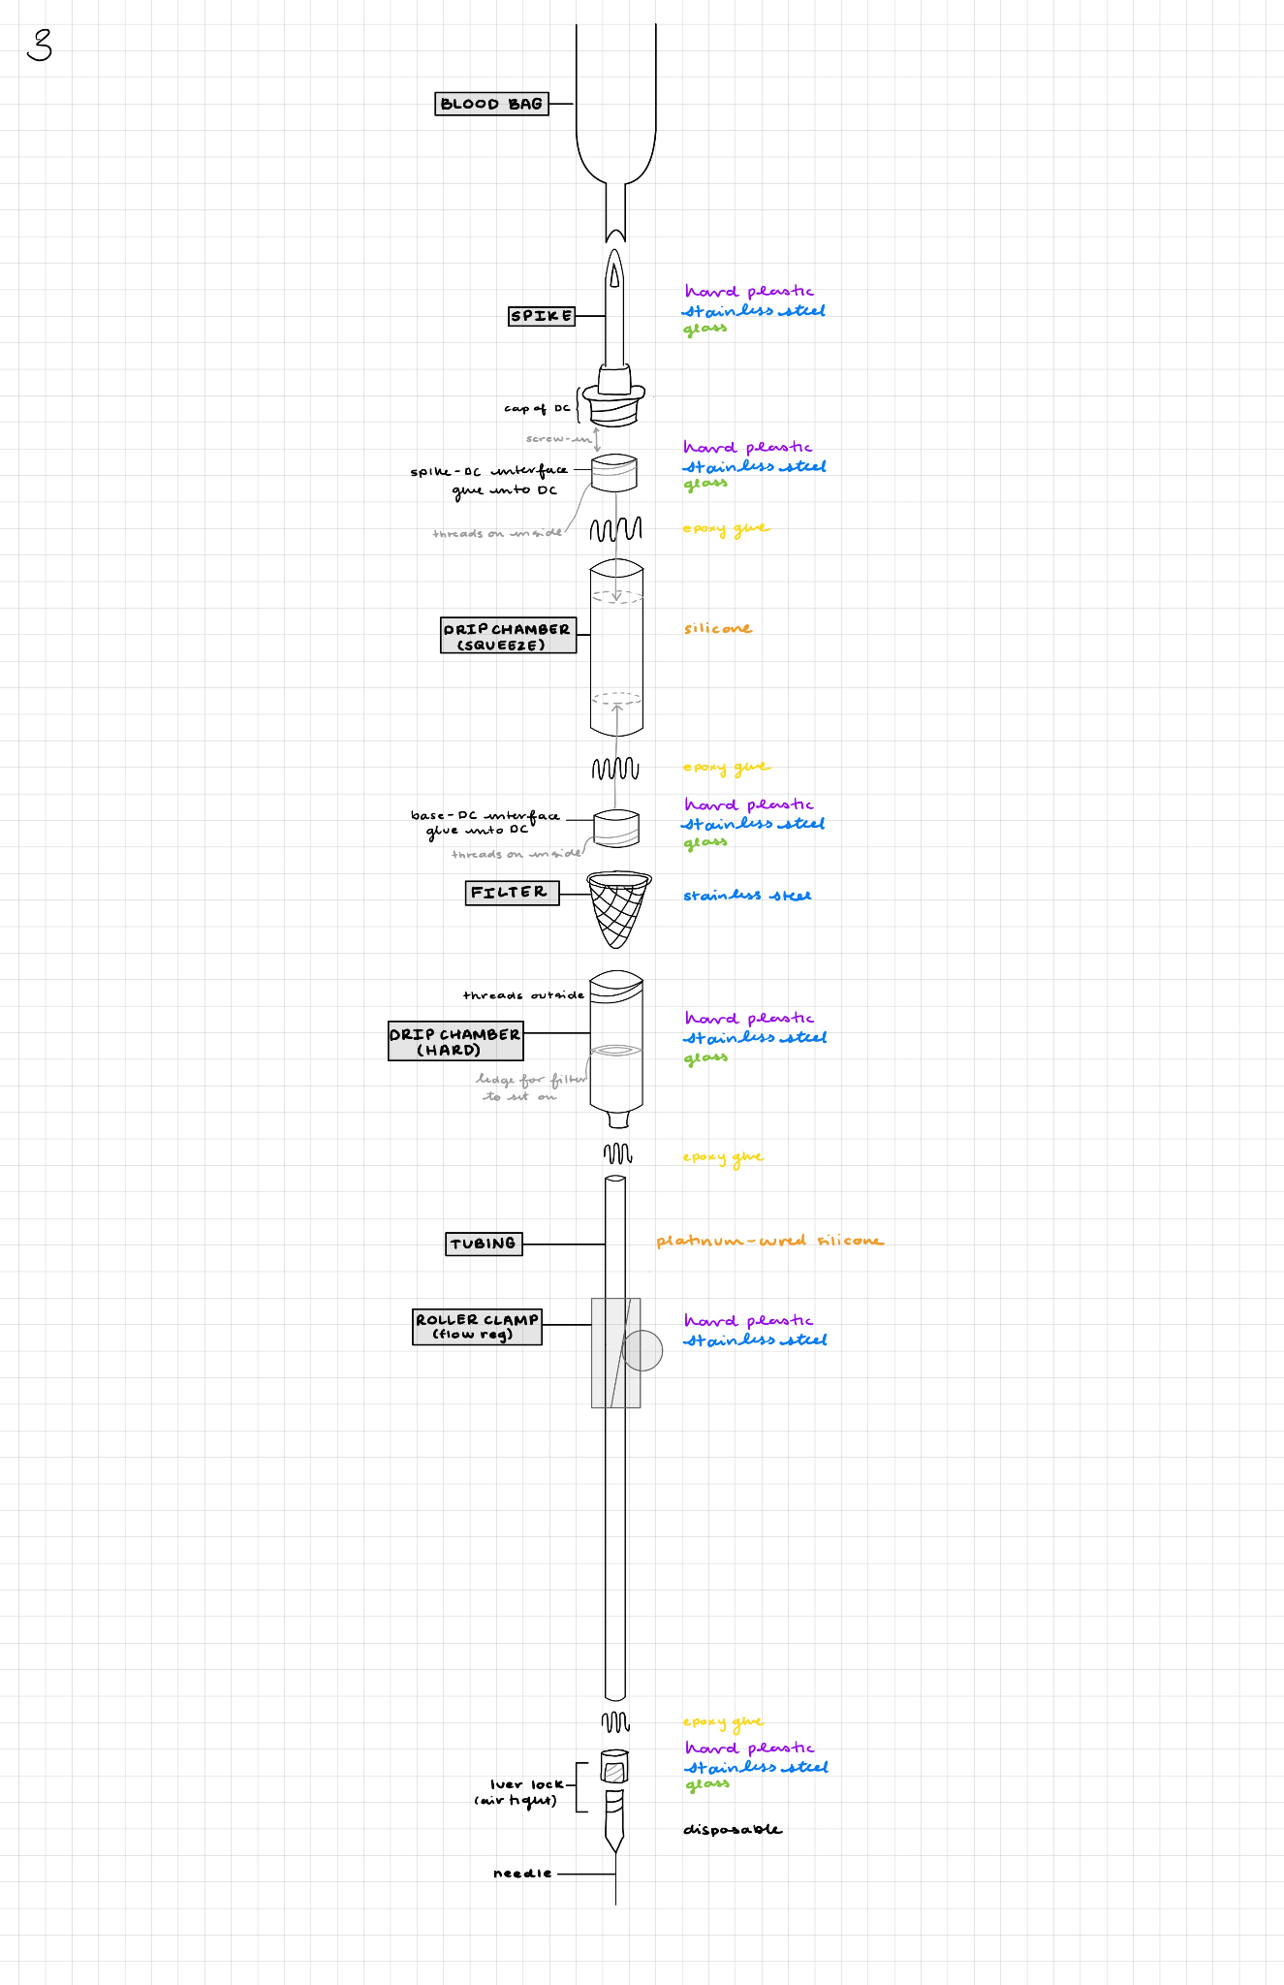

### **4.5 Design progress**

**Darcy**

I have applied my engineering knowledge during the identifying stage by utilizing the engineering design process. Specifically, during this stage, I have focused on defining the problem, identifying design constraints, and starting to brainstorm solutions. I have started and will continue to use my background in science to approach the challenge of making our design sterilizable and reusable. Understanding the basics of blood-giving and transfusions is crucial to solving our project. I plan to use my knowledge from a previous biomaterials course and apply that when selecting materials to use. I applied my math knowledge during the identifying phase to think about the cost analysis of using more expensive reusable materials instead of the current solution of single-use blood donation kits.

I plan to use my engineering knowledge and skills to create our low-fidelity prototypes during the formulation phase. I will continue to brainstorm and begin doing trade studies to gain more information about key components of the design. My understanding of science will continue to help inform what materials to use during the initial prototyping stage. Additionally, I will formulate our initial design with the science of the blood transfusion process in mind. I will use my math knowledge when formulating the design to consider the correct size of components based on the ideal drip rate for blood transfusions.

I plan to use my engineering knowledge and skills when solving our engineering design project by continuing to use the engineering design process. Specifically iterating, testing, and communication. I will iterate our prototypes and test the designs throughout the process while communicating with our client to ensure our goals are aligned. I intend to use my background in science to aid in the testing phase of solving our engineering problem. I plan to continue researching the science of blood transfusion to create the best solution. I plan to use my background in math to ensure the correct flow rate and proper operation are up to clinical standards.

## 

**Hannah**

In the identifying phase of the project, I applied my engineering knowledge by analyzing the key requirements for creating a reusable and sterilizable blood-giving set, focusing on the constraints presented by the low-resource, clinical setting in Salima. I assessed factors like material durability, design robustness, and practical implementation in the field. My understanding of medical science, particularly blood transfusions, was crucial in determining how blood interacts with various materials and the importance of maintaining sterility. This guided me in identifying materials that could endure multiple sterilization cycles while remaining biocompatible. Additionally, I applied mathematical reasoning to estimate essential parameters such as blood flow rates and the pressures the sets would need to handle, ensuring the design would be safe and effective in clinical environments.

During the formulation stage, I leveraged my engineering skills to integrate mechanical and material considerations into the design, aiming for durability and ease of use in low-resource settings. I plan to apply scientific principles from biomaterials science when selecting materials, ensuring they remain sterilizable without degrading over time and are compatible with blood. Furthermore, I will use mathematical calculations to optimize component dimensions, such as the drip chamber and spike, ensuring the design is efficient in both flow modulation and practical use.

As we progress to solving the design challenges, I will use engineering techniques to iteratively test and refine the product, ensuring it is user-friendly and durable under real-world conditions. Scientific validation will be crucial in testing material properties and biocompatibility, making sure the materials don’t cause adverse effects like contamination during blood transfusions. Finally, mathematical modeling will play a key role in refining the device’s performance, ensuring proper control of flow rate and pressure to meet clinical standards and ensure safe operation in various environments.

## 

**Jason**

## 

In the identifying phase, I applied my engineering skills to define the key challenges in creating a reusable blood-giving set, narrowing down design constraints like durability and ease of use, particularly in low-resource settings. My knowledge of blood transfusions and medical devices helped me understand the scientific challenges, especially in terms of biocompatibility and safety. I analyzed how the materials used in current devices might not be suitable for multiple uses or repeated sterilization. Additionally, I used basic calculations to assess the flow rates and pressure the blood-giving set would need to handle, ensuring the design could function without complications during transfusion.

Moving into the formulation phase, I plan to incorporate mechanical and material properties into the design to ensure the set can withstand multiple uses without failure and adhere to sterilization requirements. I will apply principles from biomaterials science to select components that maintain sterility, avoid degradation, and ensure biocompatibility with blood. I will also use calculations to optimize the design’s flow modulation and dimensions, balancing durability with efficient storage.

When solving the engineering design challenges, I will focus on integrating the mechanical design with user needs, ensuring the final product is easy to use and reliable in real-world conditions. To validate the design, I plan to use material testing and possibly simulate the blood-contacting surfaces to ensure the device functions properly without causing hemolysis or clotting. I will refine the device’s performance metrics through mathematical modeling to ensure proper flow and pressure control throughout the transfusion process.

## 

**Michaela**

Throughout my work on this project, I have effectively integrated my engineering, scientific, and mathematical expertise to identify, formulate, and solve various design challenges. In the initial identification phase, I applied my engineering skills to understand the mechanisms behind the current solutions, allowing me to pinpoint areas that required improvement. Additionally, my scientific knowledge helped me interpret literature discussing the chemical interactions of materials we considered using, along with biocompatibility testing results to ensure safety and effectiveness. Simultaneously, I employed mathematical concepts to gain a deeper understanding of how blood flow and pressure calculations are performed in clinical settings, which provided valuable insights into how doctors regulate patient blood flow and why precision in these parameters is critical.

During the formulation phase, I utilized my engineering skills to create detailed exploded diagrams that outline component specifications, ensuring that our designs could be easily implemented in practice. I drew on scientific principles to select components based on chemical reactions and testing data, using a rigorous approach to optimize material choices. Meanwhile, my mathematical knowledge was instrumental in ensuring the geometric compatibility of materials, enabling accurate construction of CAD drawings and proper fitting of components.

When solving the core engineering design project, I will rely on engineering concepts, such as evaluating mechanical stress and the tension a material can withstand, to guide testing and optimization of our designs. Utilizing the equipment and resources available on campus, I will conduct thorough evaluations to enhance material selection and performance. Scientific knowledge, particularly in microbiology, will play a role in assessing biocompatibility and maintaining sterility after autoclaving. Furthermore, mathematical skills will be applied to ensure appropriate fluid dynamics, tube sizing, and to analyze the statistical significance of our findings when comparing various design iterations. This holistic approach, combining engineering, science, and mathematics, will be essential in addressing the complex, interdisciplinary challenges inherent in our project.

WA5

**Written Assignment 5: Testing Plan and Prototype Update**

# Part 1: Testing

# Summary of testing procedures

[Blood_WA5 TestingLog.xlsx](https://docs.google.com/spreadsheets/d/1G6HR3FG4br2DhttRqDHFuhBAB7M5mJbN/edit?usp=sharing&ouid=102433198828862188964&rtpof=true&sd=true)

Since the development of our previous design criteria, we have narrowed our focus to just the blood transfusion set rather than the blood warmer. We pivoted to just the transfusion set since our team was able to easily source a blood warming device in the price range we deemed acceptable [53]. The main priority for our community partner was to have a transfusion set that would be sterilizable, which is not something already in existence. Thus, the criteria “Maintain blood at a target temperature of 36°C ± 4°C for 10-15 minutes” and “Energy-efficient” were removed.

Furthermore, we have modified our design of the transfusion set based on our observations of how to divide up the metrics we would evaluate in terms of testing. For example, we changed “Air-tight seal” to “Leakage” to encapsulate the functionality of more of our components. “Air-tight seal” would not account for the tubing or puncture wounds, it mainly focused on the interface compatibility. Our criteria of “Reusable, Durability to withstand 200 uses” was split into durability, which was subdivided into compressive strength and drop strength, and reusability was incorporated into biocompatibility and in-depth research of the bill of materials (BOM). We would not be able to conduct testing as extensive as a company in terms of durability of the material through an autoclave, so we ensured that our biocompatibility testing would account for that. For the “Portability and easy-to-use design” criteria, we maintained the ease of use criteria, but changed portability to be more of the compact sizing criteria. Lastly, the “Mechanical robustness and resistance to mechanical stress” criteria was incorporated into the durability and function requirements testing.

## 1. Safety and Serializability

### 1.1 Bacterial Removal

Based on: FDA Biocompatibility Testing of Medical Devices, Appendix P: Test Method-Specific ASCA Specifications and Summary Test Report –Bacterial Reverse Mutation Test (ISO 10993-3 and OECD 471211) A. ASCA Specifications: Bacterial Reverse Mutation Assay (i.e., Ames Assay) (ISO 10993-3 and OECD 471) [[42](https://www.fda.gov/media/182026/download)]

**Objective**

This is a verification test to determine if the device is capable of removing bacteria that may build up in the tubing after sterilization. This is critical to ensure that no bacteria enters the bloodstream.

**Equipment and instruments needed**

1. Autoclave
2. Each component of our device
3. Negative control, glass beaker
   1. Selected as standard for comparison [[42](https://www.fda.gov/media/182026/download)]
4. Phone camera
5. Bacteria stock of *Escherichia* coli

**Reusable glassware/plasticware needed**

1. Eppendorf tubes (1.5mL) x12

**Disposable materials needed**

1. Pipettes (1000µL)
2. Kimwipes
3. Agar plates for bacteria
4. Bacteria swabs for culturing
5. 15mL conicals

**Procedure**

1. Swab 1 drop of bacteria on tip of pipette from glycerol stock
   1. [62]
2. Place 5mL of LB broth into 15mL conical, place tip into 15mL conical
   1. [63]
3. Let incubate at 37ºC for 24 hours in shaker at 60 rpm
   1. Incubate in teaching lab in teer
   2. [63]
4. Take out 1mL of bacteria-broth solution, place in new 15mL conical
5. Add 9mL of water to 15mL conical for a 1:10 dilution of bacteria
6. Add 2mL of dilution to each component and negative control
7. Place on shaker at 100 rpm for 30 minutes to simulate bodily fluid passing over the material
8. Wipe down with Kimwipe for 15 seconds
9. Place in an autoclave for 40 mins at 121ºC
   1. Surgical tools are traditionally sterilized for 30 minutes at 121ºC, but we wanted to ensure that our materials could endure longer exposure to heat [64]
10. Remove from autoclave
11. Swab part with bacteria swab for culturing
12. Wipe the swab on the bacteria plate
13. Incubate at 37ºC for 24 hours
    1. Incubate in teaching lab in teer
14. Observe the percent of the area covered by colonies, take pictures
15. Import images to FIJI-ImageJ to compare the % of the surface covered by the colonies

**Criteria**

The component of our device will pass the test if it does not produce more bacteria than 1.1x the surgical-grade metal when passed through the autoclave for the prescribed number of times.

**Data Collection**

We will be taking images of the surfaces to refer back to later and will qualitatively determine the surface area of the plate covered by bacteria for the negative control, and each of our components and compare them using FIJI-ImageJ.

|  | **Resin**  **(Roller clamp)** | **Metal Mesh**  **(Filter)** | **Platinum-Cured Silicone Tubing** | **Negative Control (glass beaker)** | **Positive control (colonies in tube)** |
| --- | --- | --- | --- | --- | --- |
| **Surface %** |  |  |  |  |  |
| **Comments** |  |  |  |  |  |

### 1.2 Blood Adhesion

Based on: FDA Biocompatibility Testing of Medical Devices, Appendix J: Test Method-Specific ASCA Specifications and Summary Test Report: Direct and Indirect Hemolysis (ISO 10993-4 and ASTM F756) A. ASCA Specifications: Direct and Indirect Hemolysis (ISO 10993-4 and ASTM F756) [[42](https://www.fda.gov/media/182026/download)]

**Objective**

The objective of this verification test is to ensure that blood does not adhere to any of our components more than a surgical-grade metal.

**Equipment and instruments needed**

1. Simulated blood – 1 bottle [65]
2. Water – 200mL
3. Motorized pipette filler
4. Transfusion set components

**Reusable glassware/plasticware needed**

1. Beaker – 200mL
2. Beaker – 50mL (x2)

**Disposable materials needed**

1. Serological pipette – 10mL
2. Vacuum pipette

**Procedure**

1. Mix 100mL water and 100mL of simulated blood in a large 200mL beaker
2. Place roller clamp in 50mL beaker, add 40mL of water-blood mixture to beaker
3. Place filter and tubing in separate 15mL conicals
4. Have 1x 15mL conical with 10mL of water-blood mixture and no components
5. Have 1x 50mL beaker with 40mL of water-blood mixture and no components
6. Mix by placing on a shaker for 30 minutes at 100 rpm to simulate the passage of blood along the surface of the material
   1. Place the conicals horizontally on the shaker to ensure the blood runs through as though it were passing through the tubing
7. Extract components from the tubing and beaker, pour contents out into sink
8. Place component and negative control in autoclave at 121ºC for 40 minutes
9. Remove from autoclave
10. Take photo of component and negative control for later reference
11. Observe if any water-blood mixture is visible, qualitatively compare to amount visible on metal

**Criteria**

To pass this test, the component must not display any more red food dye than the negative control and the negative control must not have any residue.

**Data Collection**

Record images for later reference, record whether or not the red food dye was observed for the particular component being tested.

| Red coloring observed? | **Resin**  **(Roller clamp)** | **Metal Mesh**  **(Filter)** | **Platinum-Cured Silicone Tubing** | **Negative Control (glass beaker)** | **Positive control (15mL conical)** |
| --- | --- | --- | --- | --- | --- |
| **Yes** |  |  |  |  |  |
| **No** |  |  |  |  |  |
| **Comments** |  |  |  |  |  |

### 1.3 Biocompatibility

**Objective**

We will conduct a verification test to ensure that all materials used in the blood-giving sets are biocompatible, meaning they will not cause adverse reactions when in contact with blood or tissue.

**Equipment and instruments needed**

1. Bill of Materials (BOM)
2. Material Data Sheets

**Procedure**

1. Compile a comprehensive Bill of Materials (BOM) for the blood-giving sets.
2. Review data sheets for each material used in the design to verify biocompatibility.
3. Cross-check materials against biocompatibility standards (e.g., ISO 10993). [[46](https://www.fda.gov/media/142959/download)]
   1. Since most companies are able to test for biocompatibility standards to a higher degree than we are capable, we are going to ensure that they have indicated in their data sheets that they have passed the necessary tests for our purposes
4. Document materials that pass the biocompatibility criteria.

## 

**Criteria**

All materials listed in the BOM must meet biocompatibility standards with no known adverse reactions.

**Data Collection**

| Material | Data Sheet Verified (Y/N) | Biocompatibility Status (Pass/Fail) | Comments |
| --- | --- | --- | --- |

## 2. Durability

### 2.1 Compressive Strength

This parameter was established and based off of the FDA standard for “Non-Clinical Bench Testing” of medical-grade tubing under a load [[43](https://www.fda.gov/media/113959/download)].

**Objective**

The blood-giving sets must be durable enough to withstand rough handling, transport, and compressive forces in a busy clinic environment without breaking or malfunctioning. This test serves as a verification of the durability of individual components under lateral compressive forces.

**Equipment and instruments needed**

1. High-load bearing scale (1), with a load capacity of 400 lbs and a specificity of 0.1 lbs
2. Vice (1) for applying compressive force
3. Calipers (1) for measuring the dimensions of components

**Procedure**

1. Prepare the Components: Measure the initial dimensions of each component using calipers to ensure consistency in testing and proper placement.
2. Set Up the Testing Apparatus: Place the component horizontally on the high-load bearing scale, ensuring it is properly aligned for accurate force measurement.
3. Apply Compressive Force: Use the vice to gradually apply lateral compressive force. The vice pushes against the bottom of the table and the top of the component, simulating real-world lateral stress.
4. Record Maximum Load: Monitor the scale and record the maximum load applied just before the component breaks or shows signs of failure. For components that withstood the vice's maximum force without failure, record the load as ">350 lbs."
5. Repeat Testing: Perform the test twice for each component to ensure reproducibility of the results.

## 

**Criteria**

Each component must withstand a lateral compressive load of at least 200 Newtons (approximately 45 lbs) without breaking or losing functionality. Components that fail to meet this criterion will be flagged for redesign or material modification.

**Data Collection**

| Component | Trial 1 (lbs) | Trial 2(lbs | Average Failure Load (lbs) | Average Failure Load (N) |
| --- | --- | --- | --- | --- |

### 2.2 Drop Strength

This metric was based on the Medical Device Drop Test Per IEC 60601-1 Ed 3.2 Clause 15.3.4 [61]

**Objective**

This verification test determines if our components are capable of withstanding standard drop heights and maintaining their functionality afterward.

**Equipment and instruments needed**

1. Transfusion set
2. Measuring Tape

**Procedure**

1. Over a flat, concrete surface, hold up a measuring tape at 6 ft (height of blood-giving set) perpendicular to the floor
2. Obtain the transfusion set, hold it at the top of the meterstick, and drop (do not throw) the set to the floor
3. Note any damages to the component, and record in the table
4. Repeat 3 times
5. Put transfusion set back together, run water through, and look for leakage

**Criteria**

To pass this test, the component must not allow any leakage after the three drops.

**Data Collection**

| Trial # | **Spike** | **Drip chamber** | **Filter** | **Base** | **Tubing** | **Luer lock** | **Roller Clamp** |
| --- | --- | --- | --- | --- | --- | --- | --- |
| **1** |  |  |  |  |  |  |  |
| **2** |  |  |  |  |  |  |  |
| **3** |  |  |  |  |  |  |  |
| **Leakage** |  |  |  |  |  |  |  |

## 3. Functional Requirements

### 3.1 Ease of Use

**Objective**

Assess the ease of use by obtaining user feedback on our design and set up guide. We plan to approach doctors and nurses to complete this survey. (Validation Test)

**Equipment and instruments needed**

1. Setup guide (1) [Resuable Blood Transfusion User Guide (1).pdf](https://drive.google.com/file/d/1ZwfWOeiNbY0_SUa7ITpn9Z_TO_t1wHS9/view?usp=sharing)
2. Qualtrics Survey (1)
   1. Link to Qualtrics survey: <https://qfreeaccountssjc1.az1.qualtrics.com/jfe/form/SV_56kVHRRuBFYq89o>

**Procedure**

1. Create a setup guide and distribute it to healthcare professionals.
2. Have users rate the ease of use of the following four questions on a Likert scale (Strongly agree, agree, neutral, disagree, strongly disagree) 1-5.
   1. The instructions were clear on how to use the transfusion set.
   2. The setup of the transfusion set was straightforward.
   3. The flow regulator was easy to adjust with one hand.
   4. Disassembly of the set was straightforward.

## 

**Criteria**

Ease of use ratings should have ‘agree’ be the average response or a 4 or higher on a 5 Likert scale.

**Data Collection**

| User ID | Setup Time (s) | Ease of Use Rating (Likert Scale) | Comments |
| --- | --- | --- | --- |
|  |  |  |  |

### 3.2 Leakage

This test was based on the FDA standard for leakage tests in tubing involving biological materials for medical applications [[44](https://www.accessdata.fda.gov/scripts/cdrh/cfdocs/cfcfr/cfrsearch.cfm?fr=800.20)].

**Objective**

The blood-giving sets must maintain an air-tight seal to prevent contamination and ensure the safe transfer of blood. This is essential to avoid infection risks and maintain the integrity of blood during transfusion. This will be a verification test.

**Equipment and instruments needed**

1. Ziploc (1)
2. PBS Solution (2000 mL)
3. Transfusion Set (1)
4. Beaker (500mL)
5. Beaker (50mL)
6. Bin (>1000 mL)

**Procedure**

1. Fill ziplock with ~350mL of PBS
2. Set up transfusion set
3. Place bin under workspace
4. Place 500mL beaker next to bin (to receive ‘transfused’ PBS)
5. Puncture ziplock with transfusion set
6. Run the PBS through the set, ‘administering’ it into the 500mL beaker
7. Record the amount of water that leaked, in mL, by pouring it into the 50mL beaker
8. Evaluate points of leakage in tubing and connections
9. Repeat the test 5 times and record the amount of water that leaked

## 

**Criteria**

The set must be completely airtight with no PBS leakage.

**Data Collection**

| Test No. | PBS administered (mL) | PBS leaked (mL) | Points of Failure | Comments |
| --- | --- | --- | --- | --- |

### 3.3 Flow Modulation

This metric was established based on the FDA guidance for “Performance Testing of Hemodialysis Blood Tubing Sets” [[45](https://www.fda.gov/files/medical%20devices/published/Hemodialysis-Blood-Tubing-Sets---Premarket-Notification-%5B510%28k%29%5D-Submissions---Guidance-for-Industry-and-FDA-Staff.pdf)]

**Objective**

Ensure that the transfusion set provides consistent and adjustable flow rates, measured as a percentage of the maximum output at 5 modulation intervals: 100%, 75%, 50%, 25%, and 0%. (Verification Test)

**Equipment and instruments needed**

1. Ziplock bags filled with water (5)
2. Beakers (500mL)
3. Stopwatch (1)
4. Graduated cylinders (500mL)

**Procedure**

1. Fill a ziplock bag with a known volume of water.
2. Connect the blood-giving set and adjust the flow modulation to 100%.
3. Measure the output into the beaker over a set time (e.g., 30 seconds)
4. Repeat steps 2 and 3 for the remaining modulation settings by adjusting the roller to a percentage of the total throw of the flow modulator (75%, 50%, 25%, 0%). The levels of flow modulation were determined by finding where the roller was at 100 and 0. Since the slope of the regulator is linear we were able to find 75%, 50%, and 25% modulation by finding the distance between the two extremes and calculating each percentage of the distance. From our calculations, we marked the distance on our flow regulator for the tests.
5. Record the amount of water collected at each interval and calculate the percentage of water relative to the amount collected at 100%.
6. Repeat the test 3 times for each percentage of flow modulation.

**Criteria**

The flow rate at each modulation interval should match the expected percentage of the maximum flow rate within ±10%.

**Data Collection**

| Modulation (%) | Trials | Collected Water (mL) | Percentage of Max Flow (%) | Expected Flow (%) | Deviation (%) |
| --- | --- | --- | --- | --- | --- |
| 100 | Trial 1 | 473.2 |  | 100 |  |
| Trial 2 |  |  | 100 |  |
| Trial 3 |  |  | 100 |  |
| 75 | Trial 1 |  |  | 75 |  |
| Trial 2 |  |  | 75 |  |
| Trial 3 |  |  | 75 |  |
| 50 | Trial 1 |  |  | 50 |  |
| Trial 2 |  |  | 50 |  |
| Trial 3 |  |  | 50 |  |
| 25 | Trial 1 |  |  | 25 |  |
| Trial 2 |  |  | 25 |  |
| Trial 3 |  |  | 25 |  |
| 0 | Trial 1 | 0 |  | 0 |  |
| Trial 2 |  |  | 0 |  |
| Trial 3 |  |  | 0 |  |

### 3.4 Filtration

**Objective**

This test will verify that our filter is capable of separating out blood clots and large debris from the outflow. This is a verification test.

**Equipment and instruments needed**

1. Filter from blood transfusion set
2. Industry-standard blood filter from Duke Hospital
3. 212 - 300µm diameter glass beads (10g)
   1. There is not a set ‘blood clot size’ due to variance in blood clots
   2. Since our filter passes everything smaller that 180µm, we found the smallest beads, at a reasonable price, larger than this threshold to use for testing
4. Gram scale (needs to be to tenth of a mg)
5. 25mL beaker (2x)
6. Plastic square weigh boats

**Procedure**

1. Weigh industry-standard blood filter
2. Measure 100mg of 212 - 300µm glass beads in a plastic weigh boat
3. Hold filter above the 25 mL beaker, pour beads from the weigh boat through to second beaker
4. Sift filter around to let beads fall through for 15 seconds
5. Hold industry-standard blood filter above second beaker, pour contents from 25mL beaker through
6. Weight the industry-standard filter again (now it will contain any beads that our filter didn’t catch)
7. Determine and record weight of beads filtered out by industry-standard filter that were not filtered out by the filter and base from transfusion set by subtracting weight from step 1 from weight in step 5
8. Repeat 5x

**Criteria**

The filter will pass the test if less than 5mg is filtered out by the second filter.

**Data Collection**

Determine weight filtered out by the second filter.

| Trial # | 1 | 2 | 3 | 4 | 5 |
| --- | --- | --- | --- | --- | --- |
| Weight from industry-standard filter (mg) |  |  |  |  |  |
| Comments |  |  |  |  |  |

### 3.5 Compact Sizing

**Objective**

We want to ensure that our set doesn’t take up any more space than a standard blood giving set, as space is often tight in clinical and hospital settings. This will be a validation test.

**Equipment and instruments needed**

1. Blood giving set
2. Ziplock Bag
3. Calipers

**Procedure**

1. Coil our blood giving set up, and place in a ziplock bag
2. Measure the length, width, and height in inches of the device in a ziploc bag to be stored on hospital shelfs
3. Measure the length, width and heigh in inches of the commercial blood giving set within its sterylized pouch
4. Compute the total volumes of both sets

## 

**Criteria**

Confirm our dimensions are the same or smaller than the current disposable blood giving sets being used.

## 4. Community Design Requirements

For each of the following design requirements, we referenced the FDA document, “Patient-Focused Drug Development: Methods to Identify What Is Important to Patients” to ensure that the administration of tests and questions being asked would be effective tools to help us understand how to improve our project. [[49](https://www.fda.gov/media/131230/download)]

### 

### 4.1 Community Comfort

**Objective**

Assess the community's comfort with the blood-giving set design by gathering feedback through surveys. Ideally, we will survey 100 patients at the new surgical center when our device is implemented. We want to survey patients and family members who this device would be used on/ directly affecting. Our community partner will help us distribute the survey to patients. (Validation Test)

**Equipment and instruments needed**

1. Qualtrics Survey
   1. Will work with community partners to translate into language that the people in the community will understand [[49](https://www.fda.gov/media/131230/download)]
   2. Link to survey:<https://qfreeaccountssjc1.az1.qualtrics.com/jfe/form/SV_e8rvp6gxmBymOR8>

**Procedure**

1. Create a Qualtrics survey with Likert scale questions (e.g., 1-5) to assess various aspects of community comfortability with both the new design and a standard reusable set [[50](https://pmc.ncbi.nlm.nih.gov/articles/PMC4833473/)]
2. Distribute the survey online to participants in the target community.
3. Collect responses and compare the comfortability ratings between the two designs.
4. Analyze trends and identify any significant differences in comfort ratings

## 

**Criteria**

At least 80% of participants should rate the new design as more comfortable or equally comfortable as the standard set, with an average score of 3 or higher on a 5-point Likert scale.

**Data Collection**

| Respondent | Reusable Set Comfortability Rating | Disposable Set Comfortability Rating | Comments |
| --- | --- | --- | --- |

### 4.2 Local Sourcing

**Objective**

The device should be made from materials that are available or easily accessible in Malawi to ensure long-term sustainability and reproducibility. This validation test will reduce dependency on external suppliers and allow local healthcare providers to maintain and replicate the device.

**Equipment and instruments needed**

1. Bill of Materials (BOM)

**Procedure**

1. A conversation will be conducted with engineering professors/students at Malawi University of Business and Applied Sciences to inquire about the availability of materials needed to manufacture the devices
2. The following table will be filled out based on their responses.

**Criteria**

All materials are either readily available or sourceable (<1 month acquisition time).

**Data Collection**

| Component | Locally Available | Ease of Acquisition | Comments |
| --- | --- | --- | --- |
| Platinum-Coated Silicone Tubing (I.D: 3mm) |  |  |  |
| Platinum-Coated Silicone Tubing (I.D: 25.4 mm) |  |  |  |
| BioMed Resin |  |  |  |
| Epoxy |  |  |  |
| Stainless Steel Mesh (.18mm Hole) |  |  |  |

### 4.3 Cost Efficient

**Objective**

The cost of the devices must meet the budgetary constraints of the clinic and the Malawian healthcare system. These numbers are safe upper limits for cost, given by our sponsor. This validation test on affordability will ensure that the devices can be widely used and sustained in the resource-limited setting.

**Procedure**

1. Compute from Bill of Materials (BOM)

## 

**Criteria**

A cost analysis will be conducted by sourcing material quotes. We will ensure the final production cost remains under $100.

**Data Collection**

| Component | Cost Per Set | Comments |
| --- | --- | --- |
| Platinum-Coated Silicone Tubing (I.D: 3mm) |  |  |
| Platinum-Coated Silicone Tubing (I.D: 25.4 mm) |  |  |
| BioMed Resin |  |  |
| Epoxy |  |  |
| Stainless Steel Mesh (.18mm Hole) |  |  |
| Total |  |  |

## Data Schedule

| Test | Design Requirements Being Tested | Things to test/report | Start Date | Target Completion Date | Target Reporting Completion |
| --- | --- | --- | --- | --- | --- |
| Bacterial Removal | Safe and Sterilizable | % of bacteria present | 11/04/2024 | 11/06/2024 | 11/10/2024 |
| Blood Adhesion | Visibility of red food dye | 11/04/2024 | 11/06/2024 | 11/10/2024 |
| Biocompatibility | Biocompatibility according to BOM | 11/05/2024 | 11/05/2024 | 11/10/2024 |
| Compressive Strength | Durable | Maximum load at failure | 11/04/2024 | 11/04/2024 | 11/06/2024 |
| Ease of Use | High Performance | User survey feedback | 11/07/2024 | 11/11/2024 | 11/11/2024 |
| Leakage | Amount of leakage observed | 11/04/2024 | 11/04/2024 | 11/06/2024 |
| Flow Modulation | Flow rate at different modulation levels of flow regulator | 11/04/2024 | 11/04/2024 | 11/06/2024 |
| Filtration | Weight of beads filtered by industry-standard that was not filtered by our device | 11/04/2024 | 11/06/2024 | 11/08/2024 |
| Community Comfort | Compatible with Community | User survey feedback | 11/08/2024 | 11/11/2024 | 11/11/2024 |
| Local Sourcing | Local availability according to partners at Malawi Polytechnic | 11/05/2024 | 11/08/2024 | 11/08/2024 |
| Cost Efficient | Cost of materials according to BOM | 11/05/2024 | 11/08/2024 | 11/08/2024 |

## Conclusion

The outlined testing procedures are crucial in guiding our design decisions and ensuring that the blood-giving set meets the highest standards of safety, durability, and functionality. Verification testing will assess bacterial removal, blood adhesion, biocompatibility, and the compressive strength of the components. These tests will confirm whether the materials and construction can withstand the demands of repeated use and sterilization without compromising patient safety.

In parallel, validation testing will focus on usability and community factors, including ease of use, comfort, community acceptance, and local sourcing. These tests ensure that the blood-giving set is not only technically sound but also aligns with the practical needs and cultural context of the Pothawira Surgical Center. By working closely with local partners, we can assess the availability of materials and ensure the design is sustainable for long-term use.

The results from these tests will inform key design refinements. For instance, if bacterial removal tests indicate insufficient sterilization, we may explore alternative materials or sterilization methods. Similarly, if blood adhesion tests show excessive residue, we will reassess material choices or surface treatments. Any failures in these tests will prompt immediate adjustments, such as optimizing tolerances, modifying components, or sourcing better alternatives to improve performance.

Beyond the immediate implementation at the Pothawira Surgical Center, the testing process provides a foundation for scaling this design to other regions facing similar healthcare challenges. By creating iterative feedback loops, incorporating user surveys, and gathering community input, we can refine the device to remain responsive to the evolving healthcare context in Malawi. This user-centered approach ensures the device will continue to meet the needs of local healthcare providers while remaining adaptable for potential expansion to other low-resource settings.

Furthermore, insights from local sourcing and cost analysis will inform sustainable manufacturing strategies, ensuring that the device remains affordable and practical for long-term use. Ultimately, the combination of rigorous testing and continuous refinement will ensure that our final product is not only safe and effective but also culturally appropriate and economically viable, providing lasting benefits to the Pothawira Surgical Center and beyond.

# Part 2: Prototype update

# Part 2.1 Prototype update

Since WA #4, our team has made significant progress in refining the design and assembly of our blood-giving sets prototype. Each improvement is detailed below, along with justifications for the changes.

Our initial prototype was centered around an in-depth drawing that outlined the design goals for a medium-fidelity prototype. It incorporated the results from our trade studies and set the foundation for progressing to a more functional design. Since this initial version, we have made several key adjustments to each component of the device, as outlined below.

**Medium Fidelity Prototype**

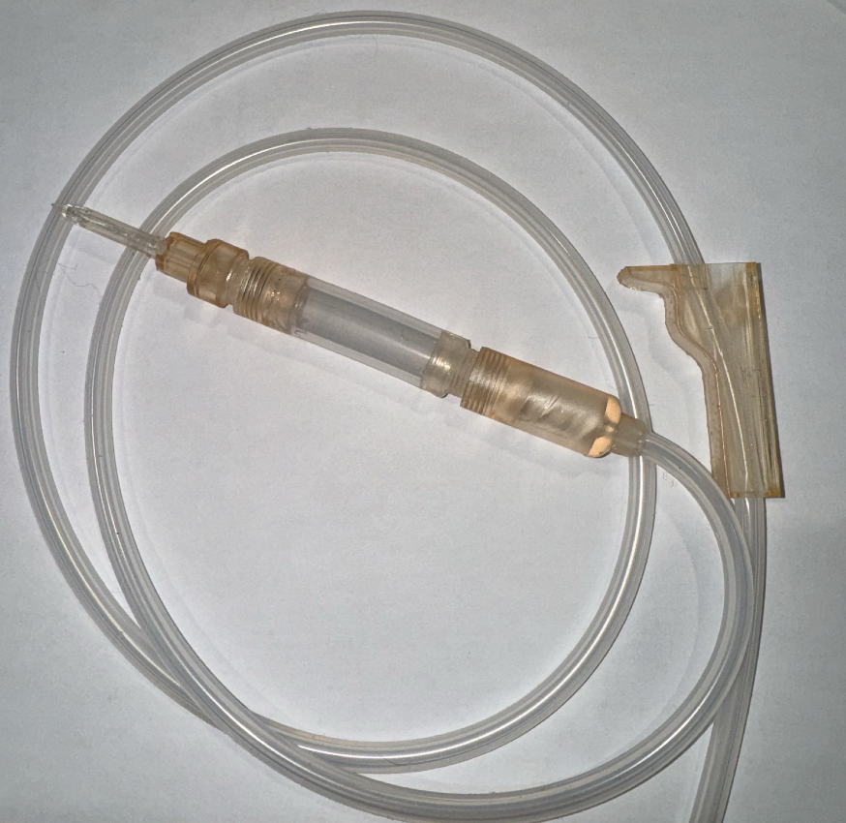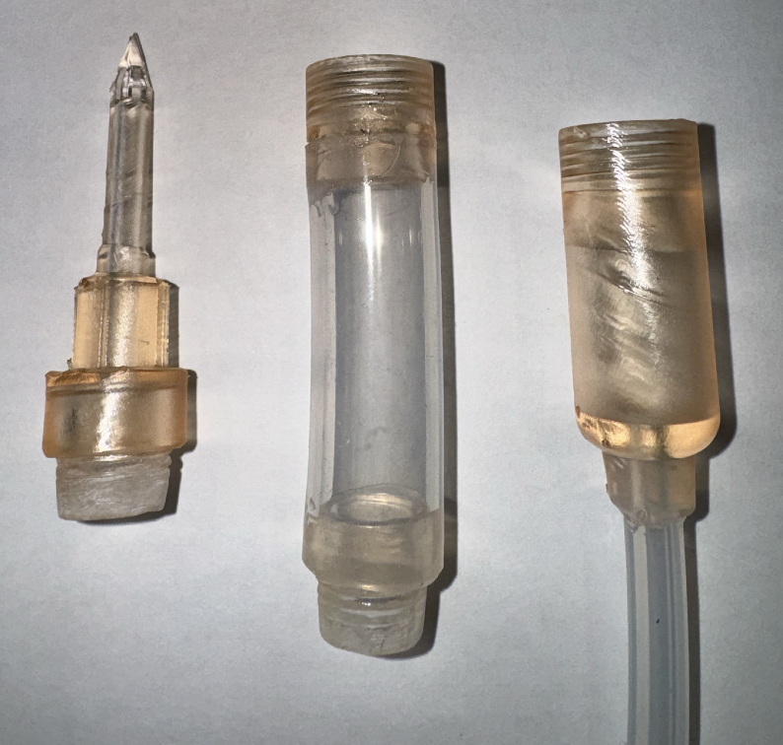

**Figure 1 (left).** Illustrates our fully composed medium fidelity prototype

**Figure 2 (right).** Displays the spike and drip chamber 3D printed components of our medium-fidelity prototype. The three components in this figure (from left to right) are the spike which screws into the top of the drip chamber, which then screws into the bottom of the drip chamber, connected to the tubing of the set.

**Spike Drip Chamber**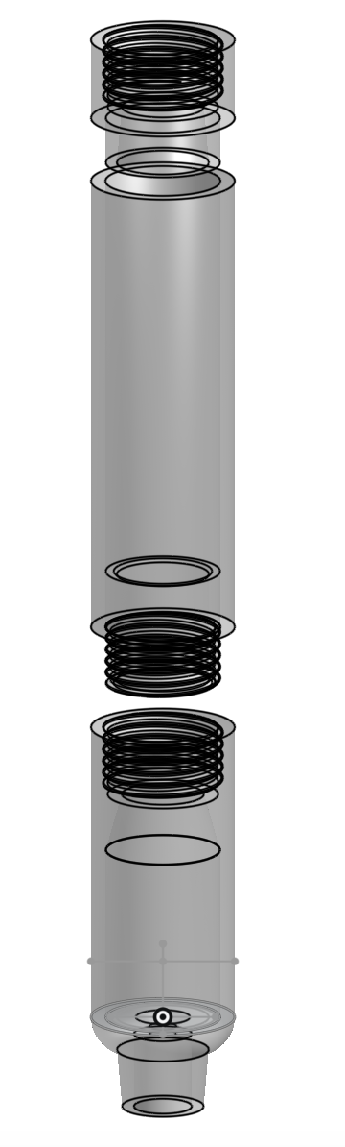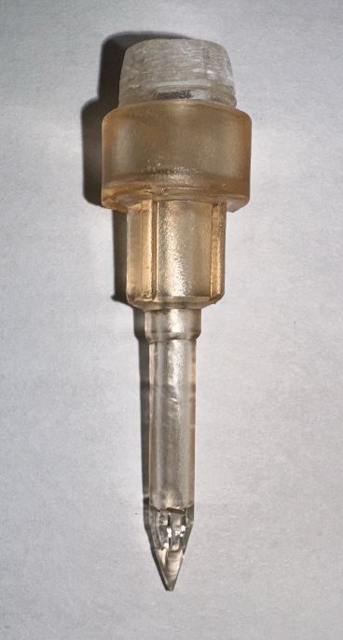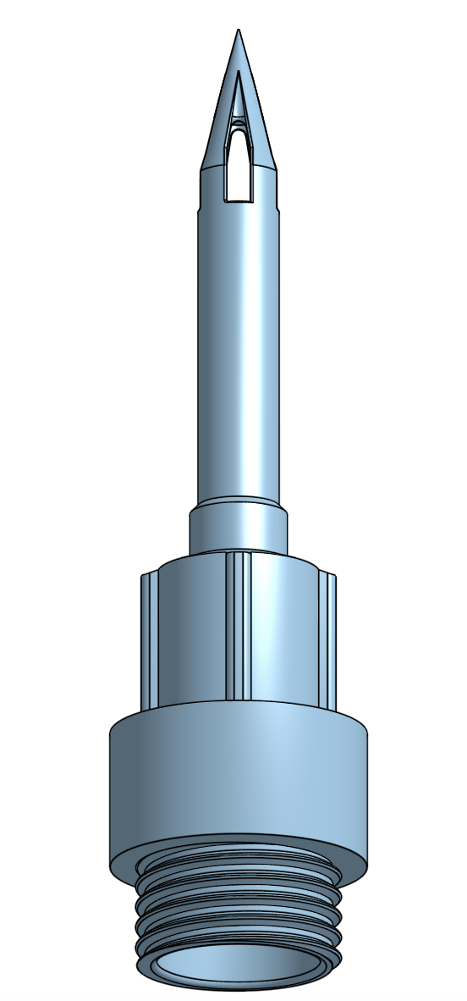

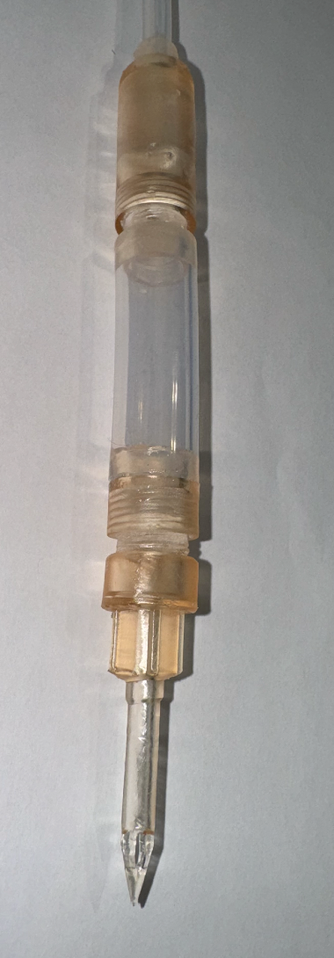

**Figure 3 (left).** Displays both the 3D printed file and the resultant printed component of the spike.

**Figure 4 (right).** Illustrates the 3D printed file and the assembly of the printed components of the drip chamber's top and bottom. The top of the drip chamber is made of large silicone-cured tubing and connected to other components through 3D-printed screw-in connectors.

In this iteration, we adjusted the threading on the spike and drip chamber components. Initially, the threads were too fine, making assembly difficult. We increased the thread size but are still working to find the perfect tolerance, as 0.3mm was still too tight in our latest test.

To assemble the set, we cut a 3-inch section of our platinum-cured silicone tubing and a 3-foot section of the thinner main tubing. These dimensions were approximate for the medium-fidelity prototype, as our primary goal was to evaluate fit and overall aesthetics. Permanent connections were made using DOWSIL flowable sealant, which was left to cure for 24 hours. This prototype satisfies our sterilizable, must-have, design criteria, as it is entirely composed of autoclavable

**Flow Regulator**

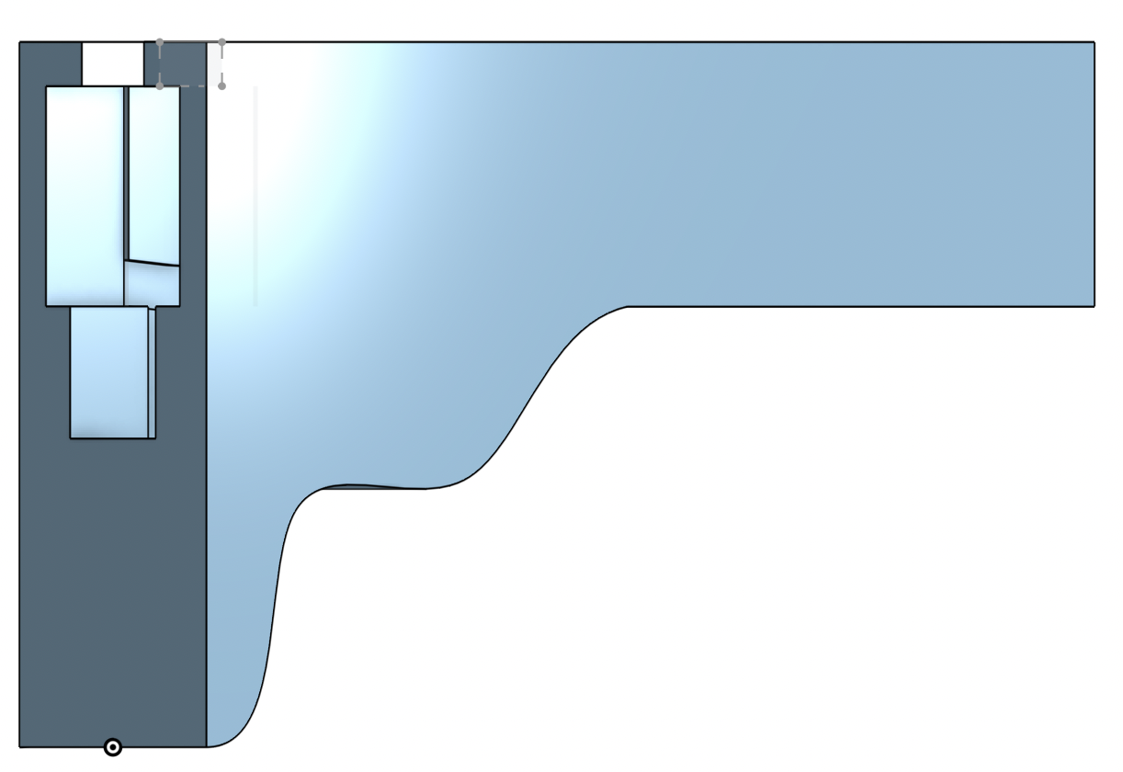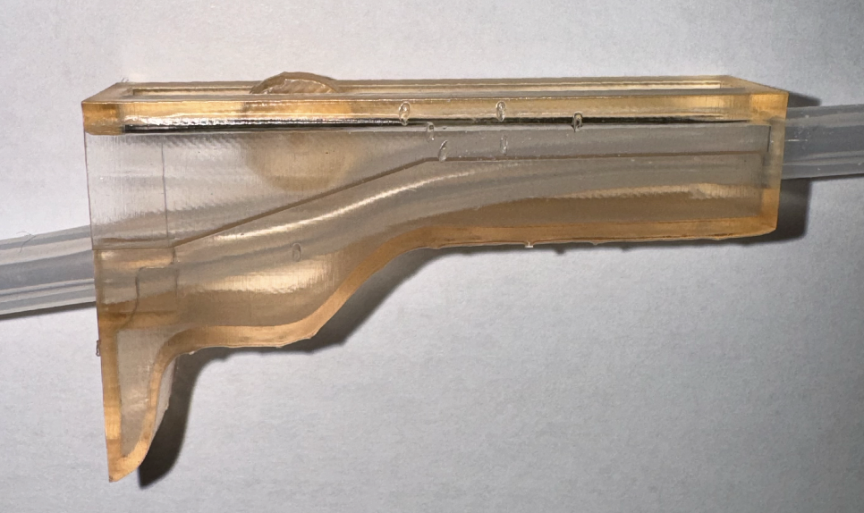

**Figure 5.** Displays 3D printed file (left) and the resultant printed component (right) of the roller clamp.

The flow regulator was attached by rolling it onto the end of the tubing. This method worked reasonably well for an initial prototype, providing basic flow modulation. However, we identified that further refinements are needed to improve the smoothness of the roller mechanism, ensuring more precise control over blood flow. Future iterations will focus on enabling gradual modulation, from fully stopped to fully open.

**Filter Cage**

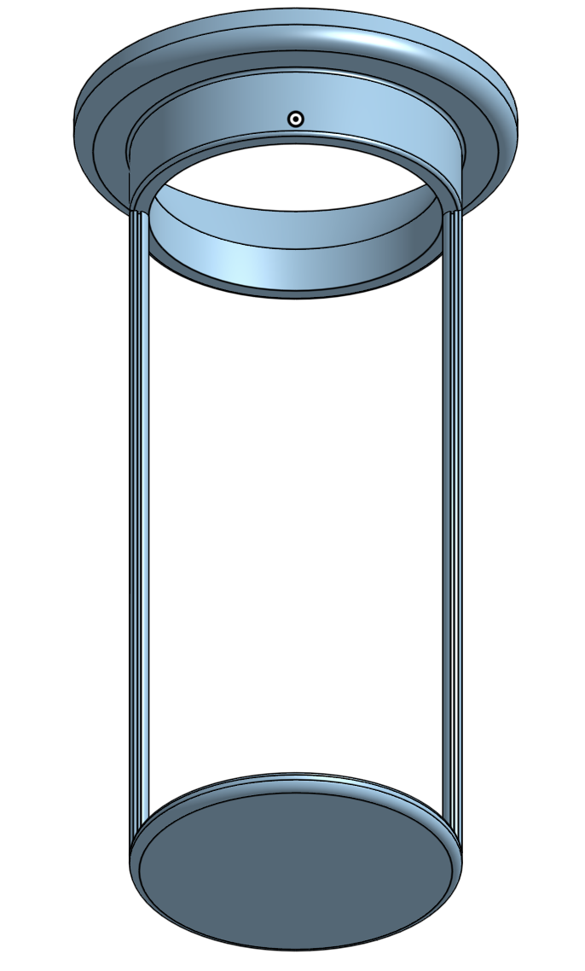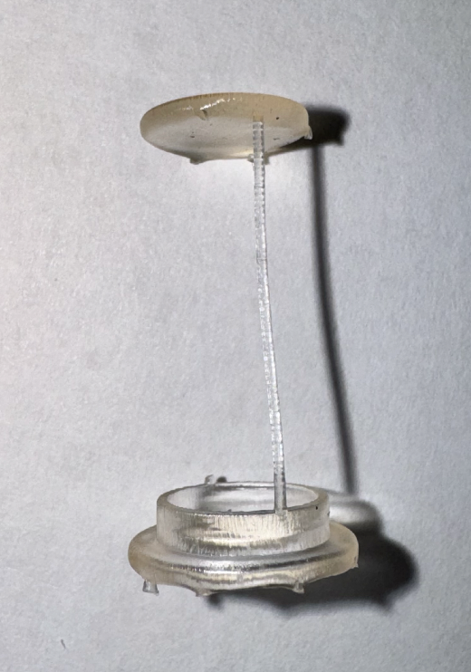

**Figure 5.** Displays 3D printed file (left) and the resultant printed component (right) of the filter cage.

The filter cage, designed to hold a metal mesh filter, slots into the rigid part of the drip chamber and rests on an internal ledge. Our initial 3D-printed model was the correct size but failed due to the sides breaking. To address this, we plan to increase the thickness of the cage's walls in the next iteration to improve structural integrity and provide support to ensure the filter is securely attached.

## Part 2.2 Prototype context

**Hannah**

Our reusable blood-giving set is designed with the primary goal of addressing the critical public health (1) needs of the Pothawira Surgical Center in Salima, Malawi. The current scarcity of single-use sets makes it difficult for clinics to provide life-saving transfusions during surgeries or medical emergencies. By creating a durable, reusable, and sterilizable set, we ensure that healthcare professionals have a reliable tool to administer blood without the constant need for resupply. This will help save lives, particularly in cases of severe trauma or postpartum hemorrhaging, where access to immediate transfusions is vital.

In terms of safety, we’ve prioritized using materials that can withstand repeated sterilization while maintaining biocompatibility (2). Our testing will ensure that the device can be autoclaved and reused without compromising patient safety, reducing the risk of infection. Welfare-wise, this solution empowers the community by offering a sustainable medical tool, reducing the need for families to find matching blood donors or rely on inconsistent supply chains (3). Culturally, we’ve considered the community’s comfort with blood and medical devices by incorporating feedback and planning to refine the design to align with local expectations (5).

Looking at the global, environmental, and economic factors, our set is designed to be cost-effective and sourced from locally available materials where possible (8,5). By minimizing the dependency on imported disposable sets, we aim to contribute to a self-sustaining medical ecosystem in Malawi (4). Environmentally, reducing medical waste from single-use devices is another significant benefit, supporting the long-term sustainability of the project (7). Socially, we’re focused on ensuring that our device is user-friendly for both clinicians and patients, making healthcare more accessible and efficient (6). All of these factors work together to support a holistic approach to improving public health in Malawi.

**Darcy**

Our reusable transfusion set will meet the needs of the Pothawira Surgical Center in Salima, Malawi, which requires an affordable, reusable, and sterilizable method for blood-giving sets to address the limited availability of single-use sets. Our solution addresses the public health need for blood-giving sets for surgeries in Malawi. Currently, family members with the same blood type come with the patient to give blood, our set eliminates the need for this by providing a safe and reliable device for blood transfusion. Our design meets the safety requirements of our community as all components of our solution are sterilizable in the autoclave that will be on site. Patients are currently dying due to lack of blood during surgeries or when complications occur such as post-partum hemorrhaging. The transfusion set addresses the welfare of the Malawi community by providing a reliable way to transfusion blood, allowing for safe surgeries to be performed. Our design is planned to be made from locally sourced materials and low cost for global, environmental, and economic factor considerations. The limited supply of transfusion sets controlled by the Malawian government further motivates us to create an accessible solution that reduces reliance on imports and supports the local supply chain. Furthermore, for environmental considerations we want to decrease reliance and need for single-use plastics, reducing waste in the community. Another aspect of our project is understanding and respecting cultural perceptions of blood, especially given its sacred role in Malawian communities. We are incorporating a user survey to gauge community comfort to make sure our design will be accepted by the community. We aim to create a non-intimidating, approachable design that aligns with cultural sensitivities. Our holistic approach to this design project prioritizes both medical safety and community comfort, with the ultimate goal of creating a functional transfusion set that is also accepted by the community.

**Michaela**

The current design solution we have has been constructed with the community and its needs at every step.

1. Our final design will benefit the health of the people of Malawi by providing them with the necessary tools for emergency medical procedures. Before, they would run out of sets and frequently be unable to perform procedures. Our product should change that since they do not need consistent access to the disposable sets.
2. After extensive testing, we will be able to ensure the safety of the patient and medical professionals using our device. Testing must be rigorous and detailed to ensure maximal biocompatibility and minimal health risk. This is particularly hard for a reusable set which is why so many of our metrics relate to the safety of our device.
3. Since our product is constructed completely of industry-tested sterilizable materials. This is critical to meeting the design requirements set forth by our client such that they can have a supply of transfusion sets despite not having sufficient access to disposable sets. This will overwhelmingly benefit the community by eliminating the possibility that a life-saving transfusion may not occur if there are no sets available. It also limits the need to travel extensively to obtain a disposable set.
4. Our product is mainly focused on benefiting the community of Salima, Malawi and thus we are not aiming to optimize its use on a global scale. If we focused on the globalization of our product, we would likely fail to meet the needs of the community we are working with. This is exactly what happened with the standardization of disposable sets.
5. Our product testing metrics outlined under “Community Design Requirements” aim to identify whether or not our product will fit the culture of the community or if there are steps we should take in making our final design more compatible with the community. There is a lot of stigma around blood donations in the culture, so we will work on education outreach to improve the sentiment toward donating.
6. The social factors of our product include the community comfort with blood and lack of knowledge on the subject which makes it much scarier. We aim to assess this with the “Community Design Requirements.” To improve outcomes, we will work with our community partner to improve the design or explanation/education on what it does.
7. Since our transfusion set is entirely sterilizable, we believe that the environmental impact will be less than what a traditional disposable set would incur. We hope that this design could potentially be applied in the public health sector in other countries as well to diminish the waste produced by single-use sets.
8. Our project aims to lower cost for the blood sets and will be evaluated with “Cost Efficiency”

**Jason**

Our current design for the reusable blood transfusion set is driven by the critical healthcare challenges faced by our community partner in Malawi, particularly the need for more reliable and accessible blood transfusions in low-resource settings (1). From a public health standpoint, we’ve been focused on creating a solution that addresses the urgent need for equipment that can help manage emergencies like postpartum hemorrhage, which is a leading cause of maternal mortality in the region (1). By designing a sterilizable and reusable transfusion set, we aim to reduce the dependency on single-use devices that are often difficult to source in rural areas, making transfusions more consistent and accessible when they are needed most (3). This low-cost approach directly aligns with Malawi’s economic challenges, where maintaining a stock of disposable transfusion sets presents a significant financial burden on healthcare facilities (8).

Safety has been a top priority throughout this process (2). Our design minimizes contamination risks through the use of screwable connections to create airtight seals, and we’ve been careful in selecting materials that comply with international safety standards, such as ISO 1135 (2). This not only ensures patient safety but also protects healthcare workers by reducing the risk of needle-related injuries and simplifying device handling in a fast-paced medical environment (2).

When considering the welfare of the community, the reusable nature of the design is intended to relieve healthcare providers from the constant financial and logistical strain of sourcing disposable sets (3). With a reusable option, facilities can focus more on patient care, rather than struggling to maintain an inventory of single-use supplies (3). In addition, we’ve integrated global considerations into our design to make it adaptable for use in other low-resource settings that face similar healthcare challenges (4). The simplicity of the design means it can be easily manufactured and adjusted to suit different regions, helping improve access to care on a broader scale (4).

Culturally, we’ve worked to ensure that this product can be smoothly integrated into the medical practices already established in Malawi without requiring extensive retraining (5). This is crucial because it ensures healthcare workers are comfortable and confident using the new system, thus increasing its adoption and effectiveness (5). From a social perspective, increasing the reliability and accessibility of transfusions has the potential to strengthen trust in local healthcare, particularly in rural communities where access to advanced medical resources is already limited (6).

Environmental considerations have also played a major role in the design process (7). By opting for a reusable system, we aim to significantly reduce medical waste, which is a growing problem in regions where waste management infrastructure is limited (7). Finally, economically, the reusability of the transfusion set promises substantial long-term savings for healthcare facilities that would otherwise need to continually purchase expensive single-use devices (8). This aligns directly with Malawi’s healthcare budget constraints, making the design not only practical but sustainable for ongoing use (8).

WA6

**Written Assignment 6: Testing report, iteration plan based on partner feedback**

Part 1: Testing Results

# 6.1 Verification Tests

# 

# Bacterial Removal

|  | **Resin**  **(Roller clamp)** | **Metal Mesh**  **(Filter)** | **Platinum-Cured Silicone Tubing** | **Negative Control (glass beaker)** | **Positive control (colonies in tube)** |
| --- | --- | --- | --- | --- | --- |
| **Surface %** | 0 | 0 | 0 | 0 | 36% |
| **Comments** | No bacteria, resin turned clear, no other deformation | No bacteria, no material deformation | No bacteria, no material deformation, bubble in resin | No bacteria, no material deformation, scratch from plating | Many colonies |
| **Images inputted into ImageJ** |  |  |  |  |  |

**Table 1.** Bacteria Removal Test Results

Since our design has gone through many iterations, we wanted to establish the bacterial adhesion properties of our materials without the confounding factor of their shape or construction. Results from this study are useful as a baseline for when we conduct it on each of our components in the future to determine if it is the material or the shape that has contributed to bacterial adhesion. Here, we tested the material only to see if it would grow bacteria.

We chose the roller clamp because it was the most open and least likely to retain bacteria due to its shape in a steam sterilizer, removing the confounding factor of shape as a possibility for why the bacteria might grow on the component. The metal mesh is a unique component not used elsewhere in the set, so it was used to determine the sterilizability of the filter. The small-diameter platinum-cured silicone tubing was used to determine if the bacteria would grow in a 4-inch long segment and establish a baseline for the depth to which the steam sterilization would reach. Swabs were taken from the middle part of the tubing to ensure the steam was able to reach the center of the 4-inch long segment. For the negative control, a glass beaker was selected because they are sterilized frequently in autoclaves and are commonly used in bacterial work so it is necessary for them to be completely sterilizable when in contact with bacteria. For the positive control, a bacterial culture tube that was not autoclaved was used. It had 2mL of E. coli inside of it on a shaker, which was then removed and swabbed with the same swabbing techniques used as the other materials.

Autoclaving was conducted for 40 minutes at 121ºC. The standard time for autoclaving surgical tools is traditionally 30 minutes at 121ºC, however, we wanted to ensure our materials could endure slightly more intensity of sterilization, and the 40 minutes is what is typically used to sterilize our negative control, the glass beaker in the BME teaching lab [64].

ImageJ was used to quantify colony % based on area covered by colonies. This way, the metric could be standardized rather than estimating the amount of colonies seen to the eye.

Our results show that none of our materials cultivated bacteria after autoclaving, meaning that they are able to be sterilized completely in an autoclave. We also know that this testing is accurate because our negative control did not grow bacteria while our positive control showed significant amounts of colonies.

However, the possibility that endotoxins from bacterial residue could remain on the surface was not reliably tested for this portion of the experiment. These have the potential to cause an acute immune reaction and induce septic shock. The most common way of testing for endotoxin presence on the surface of a material is the clotting method. This method involves running horseshoe crab blood cells over the surface, which clot in the presence of endotoxins, however this method is very expensive. [66].

Our materials pass the bacterial testing, but future testing will need to be conducted to evaluate if the physical design of our material impacts their capacity to be autoclaved. This will be particularly important to repeat for the long tubing since there is the concern that the longer tubing may not be able to be sterilized with an autoclave as the steam may not reach completely inside.

# Blood Adhesion

1.1 Testing Results

|  | **Resin**  **(Roller clamp)** | **Metal Mesh**  **(Filter)** | **Platinum-Cured Silicone Tubing** | **Negative Control (glass beaker)** | **Positive control (15mL conical no autoclaving)** |
| --- | --- | --- | --- | --- | --- |
| Red dye present after autoclaving (or before for the + control)? | Yes | Yes | Yes | Yes | Yes |
| Comments |  |  |  |  |  |
| After red dye |  |  |  |  |  |
| After autoclaving |  |  |  |  | N/A |
| After rinse |  |  |  | Beaker was clear of any red dye | N/A |

**Table 2.** Blood Adhesion Test Results

Similar to the bacterial removal test, this was a test to establish a baseline level of blood adhesion for our materials without the shape and design being confounding factors. This is to remove the possibility that it is the material rather than our shape/design causing the adhesion. In this way, we would know to change the material before changing our design. For similar reasons stated in the bacteria testing explanation, the roller clamp was selected to test the resin used, the metal mesh was used to test the filtration component, and the small-diameter platinum-cured silicone tubing was used to test the tubing. A glass beaker was once again chosen as the negative control since they need to be sterilizable for applications in a biological setting.

Autoclaving was conducted with a series of other tools that were in plastic autoclaving bags, necessitating that our materials be placed in the bags as well. Given that our materials had the simulated blood (red dye) on them, the bags were a precautionary method to prevent cross contamination.

Autoclaving was conducted for 40 minutes at 121ºC. The standard time for autoclaving surgical tools is traditionally 30 minutes at 121ºC, however we wanted to ensure our materials could endure slightly more intensity of sterilization, and the 40 minutes is what is typically used to sterilize our negative control, the glass beaker in the BME teaching lab [64].

Simulated blood was left in all of the components, including the positive control, indicating that there is an issue with the experimental setup and conclusions drawn from this data will need to be verified in future iterations of this testing.

Since our test was to compare the amount of blood left in the negative control with the amount of blood left in each of the components, it seems that our test passed the first half of the parameters, but our test failed to fully sterilize the glass beaker indicating that our test failed. Liquid was still in all of the compartments, including the negative control, and the test should be repeated without the use of autoclave bags to more closely simulate the processing that will happen to them in the clinic.

In the future, the sterilization procedures will need to include a test that evaluates their mechanical performance after

# Biocompatibility

The objective of this verification test was to ensure that all materials used in the blood-giving sets are biocompatible, meaning they would not cause adverse reactions when in contact with blood or tissue.

To complete this test, we reviewed the data sheets for each material and component in our design to verify their biocompatibility. This verification was conducted by confirming that our suppliers had performed the necessary biocompatibility testing, aligning with ISO 10993 and related standards. Each material must meet these standards with no known adverse reactions.

| Material | Data Sheet Verified (Y/N) | Biocompatibility Status (Pass/Fail) | Comments |
| --- | --- | --- | --- |
| Platinum-Coated Silicone Tubing (I.D: 3mm) | Y | Pass | Meets ISO 10993 standards and USP Class VI tests56 |
| Platinum-Coated Silicone Tubing (I.D: 25.4 mm) | N | Pass | No technical data sheet was available so we had to go off of the product description. The description states “FDA Food & Medical Grade Silicone”60 |
| Biomed Amber Resin | Y | Pass | Verified against ISO 10993-1 and other standards; non-cytotoxic, non-pyrogenic57​ |
| Dowsil 734 Flowable Sealant | Y | Fail | Passes MIL-A-46106 but not intended for medical use. Product not tested for prolonged blood contact58 |
| Stainless Steel Mesh (.18mm Hole) | N | Pass | No technical data sheet was available so we had to go off of the product description which states the material as “304 Stainless Steel”. This material is widely recognized as biocompatible and suitable for medical applications​59 |

**Table 3.** Biocompatibility Assessment of Blood-Giving Set Materials

Our findings are summarized in the table above. The majority of the materials passed the required biocompatibility standards, either through verified data sheets or product descriptions indicating compliance with ISO 10993 and similar standards. Notably, the platinum-coated silicone tubing and stainless steel mesh, despite lacking detailed technical sheets, were supported by product descriptions indicating medical-grade quality. However, the Dowsil 734 Flowable Sealant failed due to its lack of certification for medical use. Due to this, the overall outcome of the test is a Fail. Moving forward, we will consider sourcing an alternative selant to ensure compliance.

# Compressive Strength

A workaround testing method was employed to assess the compressive strength of the individual components in our blood transfusion set due to limited access to a formal load cell. This test was crucial to ensure that all components could withstand the expected loads during use, particularly in the lateral direction, which is both the weaker orientation and the most likely to experience stress due to the attached tubing in the assembled set. Our target for each component was to sustain a load of at least 200N.

The setup involved placing each component on a high-load-bearing scale while compressing it laterally using a vice. The vice was used to apply force against the bottom of the table and the top of the component until failure occurred. The scale used had a load capacity of 400 lbs and a specificity of 0.1 lbs, ensuring precise measurements up to the limit. For components that sustained loads exceeding 350 lbs, testing was stopped to avoid exceeding the scale’s capacity, and those results are reported as ">350 lbs."

| **Component** | **Trial 1 (lbs)** | **Trial 2 (lbs)** | **Average (lbs)** | **Average (N)** |
| --- | --- | --- | --- | --- |
| Lower Assembly | >350 | >350 | >350 | >1556.9 |
| Spike | >350 | 262 | 306 | 1361.2 |
| Female Connector | 157 | 259 | 208 | 925.2 |
| Male Connector | 81 | 46 | 63.5 | 282.5 |
| Luer Lock | 305 | — | 305 | 1356.7 |

**Table 4.** Compression Test Outputs

The results indicate that all components, except for one of the male connectors, significantly exceeded the 200 N target load in their lateral orientations. The male connector, which failed at an average load of 282.5 N, barely met the target, and its relatively lower failure point suggests this component may require reinforcement. The lower assembly and spike showed particularly strong performance, each withstanding loads over 1300 N, which provides a significant safety margin. The female connector also exceeded the target, averaging 925.2 N.

While most components passed the compressive strength test, the male connector's marginal performance indicates it may need design modifications to enhance its durability. Since only lateral testing was conducted due to limited component supply, future iterations will aim to test all components in both axial and lateral directions to ensure comprehensive validation. Additionally, sourcing more components would allow further testing to confirm these results and evaluate potential improvements.

# Drop Test

To assess the drop strength and durability of our material we conducted a drop test per Medical Device Drop Test Per IEC 60601-1 Ed 3.2 Clause 15.3.4 [61]. For this test, we dropped the whole transfusion set from 6 feet, which is the normal height of a blood bag for blood transfusion. We dropped the set three times for more accurate data and analyzed each component after each drop. After the three drops, we then planned to assess any points of leakage in the set by performing another leakage test, post drop test.

| **Trial #** | **Spike** | **Drip chamber** | **Filter** | **Base** | **Tubing** | **Luer lock** | **Roller Clamp** |
| --- | --- | --- | --- | --- | --- | --- | --- |
| **1** | - | - | - | - | - | - | - |
| **2** | Spike broke off | - | - | - | - | - | Some material broke off the side |
| **3** | Broken in the previous trial | - | - | - | - | - | More material broke off the side |
| **Leakage** | Fail | Fail | Fail | Fail | Fail | Fail | Fail |

**Table 5.** Points of failure from drop testing.

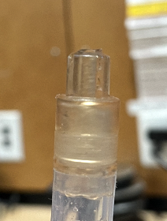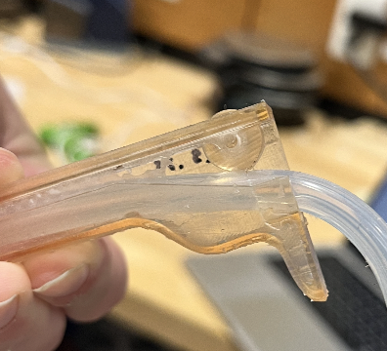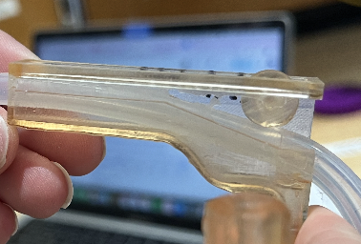

**Figure 1,2,3.** From left the right: the broken spike, flow regulator after trial 2, flow regulator after trial 3.

Our findings highlight our device had two points of failure resulting from the drop test. On our second trial, our spike broke off cleanly as shown in Figure 1. Additionally, our flow regulator had some side material missing initially, after our second trial we found that more material had broken off as shown in Figure 2. For our third trial more material broke off from the flow regulator as shown by Figure 3. Due to our spike breaking off, we were unable to perform a leakage test and therefore we failed this test for all components since the set was not fully functioning.

Based on the results, we failed the criteria for this test. We are currently iterating our flow modulator and spike to be more robust and plan to retest this criterion with our next prototype.

# Flow Modulation

To evaluate the performance of the flow regulator we conducted a flow rate test based on the FDA guidance for “Performance Testing of Hemodialysis Blood Tubing Sets” [[45](https://www.fda.gov/files/medical%20devices/published/Hemodialysis-Blood-Tubing-Sets---Premarket-Notification-%5B510%28k%29%5D-Submissions---Guidance-for-Industry-and-FDA-Staff.pdf)]. For this test, the transfusion set was fully assembled, we used a Ziploc bag and water in place of a blood bag and human blood. We conducted each level of flow modulation three times for more accurate results. The levels of flow modulation were determined by finding where the roller was at 100 and 0. Since the slope of the regulator is linear we were able to find 75%, 50%, and 25% modulation by finding the distance between the two extremes and calculating each percentage of the distance. From our calculations, we marked the distance on our flow regulator for the tests.

| **Modulation (%)** | **Trials** | **Collected Water (mL)**  Expected: 476.1 mL | **Percentage of Max Flow (%)** | **Expected Flow (%)** | **Deviation (%)** |
| --- | --- | --- | --- | --- | --- |
| 100 | Trial 1 | 473.2 | 100 | 100 | 0 |
| Trial 2 | 443.6 | 93.7 | 100 | 6.3 |
| Trial 3 | 467.3 | 98.7 | 100 | 1.3 |
| 75 | Trial 1 | 360 | 75.9 | 75 | 1.2 |
| Trial 2 | 390 | 82.3 | 75 | 9.7 |
| Trial 3 | 500 | 105.5 | 75 | 40.7 |
| 50 | Trial 1 | 490 | 103.4 | 50 | 106.8 |
| Trial 2 | 470 | 99.2 | 50 | 98.4 |
| Trial 3 | 500 | 105.5 | 50 | 111 |
| 25 | Trial 1 | 225 | 47.5 | 25 | 90 |
| Trial 2 | 400 | 84.3 | 25 | 237.2 |
| Trial 3 | 400 | 84.3 | 25 | 237.2 |
| 0 | Trial 1 | 0 | 0 | 0 | 0 |
| Trial 2 | 0 | 0 | 0 | 0 |
| Trial 3 | 0 | 0 | 0 | 0 |

**Table 6.** Results of flow modulation test

As shown by Table 6., our flow modulator performs well at 100% and 0% flow modulation. However, failed to successfully modulate the flow between these values. Our calculations for the percentage of max flow can be found in our Appendix. We hypothesize this failure was due to some of the material on the side of our flow regulator. We are reiterating our flow regulator and plan to retest the flow modulation. Additionally, when the flow modulator was at zero, our drip chamber filled with water and leaked at connection points. While our device passed our initial leakage testing, we found that the test was not a good metric to assess the leakage of our device.

Based on the results, we failed the criteria for this test. With our next prototype, we plan to re-test leakage with a more robust testing plan.

# Leakage

To assess the potential for leakage of the transfusion set we employed a leakage test. For this test, the transfusion set was fully assembled to resemble the set being used for blood donation. We struggled to find blood bags, so we used Ziploc bags as a substitute. Similarly, human and animal blood is difficult and costly to obtain so we swapped in water in place of blood for this test.

| **Test No.** | **PBS administered (mL)** | **PBS leaked (mL)** | **Points of Failure** |
| --- | --- | --- | --- |
| 1 | 350 | 0 | N/A |
| 2 | 350 | 0 | N/A |
| 3 | 350 | < 0.1 mL | Spike into Ziploc Bag |
| 4 | 350 | 0 | N/A |
| 5 | 350 | 0 | N/A |

**Table 7.** Result of leakage testing with Ziploc bag of water and transfusion set prototype.

As shown by Table 7. above, the transfusion set had no points of leakage for four of the five tests. On the third test, a very small amount of leakage occurred. The amount of water was small enough not to register on the scale when trying to quantify the amount of leakage. After the conclusion of this test, we found it to be a success. The one test where a small amount of leakage occurred was suspected to have occurred due to poor seal due to the spike puncturing the blood bag. We did not believe that was a fault of our design functionality and planned to conduct further testing with direct water administration from a syringe to the spike to confirm the leakage was not due to our connections in the transfusion set.

Based on our results, our leakage test passed our criteria. However, as discussed in the flow modulation testing, we plan to retest this for a more accurate and robust leakage test.

# Filtration

This test aimed to verify that our filter is capable of separating blood clots and large debris from the outflow, ensuring effective filtration during use.

We conducted a verification test using 212 - 300µm glass beads to simulate large particles. The test compared our filter's performance against an industry-standard blood filter from Duke Hospital. The process involved putting the beads through our filter, and then the industry standard filter. We accounted for any beads that the industry filter picked up that ours let pass by weighing the industry standard filter befor and after each trial. If our filter filtered out everything it should as expected, we would expect the change of weight of the industry standard filter to be 0.

| Trial No. | Weight of Glass Beads (mg) | Original Weight of Industry Standard Filter (mg) | Weight of Industry Standard Filter after filtration (mg) | Weight of Beads Filtered by Industry Standard Filter (mg) |
| --- | --- | --- | --- | --- |
| 1 | 100.9 | 1523.9 | 1523.9 | 0 |
| 2 | 106 | 1523.9 | 1523.8 | -0.1 |
| 3 | 126.8 | 1523.9 | 1524 | 0.1 |
| 4 | 113.1 | 1523.9 | 1524 | 0.1 |
| 5 | 119.2 | 1523.9 | 1523.8 | -0.1 |
|  | | | | **Average = 0** |

**Table 8.** Filtration Test Outputs

The average weight difference across five trials was 0.0 mg, which is well below the 5 mg threshold for test failure. This confirms that our filter effectively captured all relevant particles, matching the industry standard. The slight deviations of ±0.1 mg are likely due to scale variability, as the weight in two instances suggested a loss of 0.1 mg, which is not physically feasible.

Based on these results, the filtration test was a success. Our filter meets the criteria for removing large debris, ensuring its safety and efficacy in clinical use.

**6.2 Validation**

# Ease of Use

To gauge how easy and intuitive our device is we created a user guide detailing each of our components and a step-by-step process of how to assemble and disassemble our device. The user guide can be found here [Resuable Blood Transfusion User Guide (1).pdf](https://drive.google.com/file/d/1ZwfWOeiNbY0_SUa7ITpn9Z_TO_t1wHS9/view?usp=sharing). To assess the ease of use we asked ten classmates to assemble our device and use the flow modulator based on a quick tutorial and the user guide. We then had the participants fill out a four-question survey about the ease of use of our device.

| **Question #** | **Question** | **Score** |
| --- | --- | --- |
| **Q1** | The instructions were clear on how to use the transfusion set. | 4.7 |
| **Q2** | The setup of the transfusion set was straightforward. | 4.9 |
| **Q3** | The flow regulator was easy to adjust with one hand. | 4.8 |
| **Q4** | Disassembly of the set was straightforward. | 4.6 |

**Table 9.** Displays the questions asked on the survey

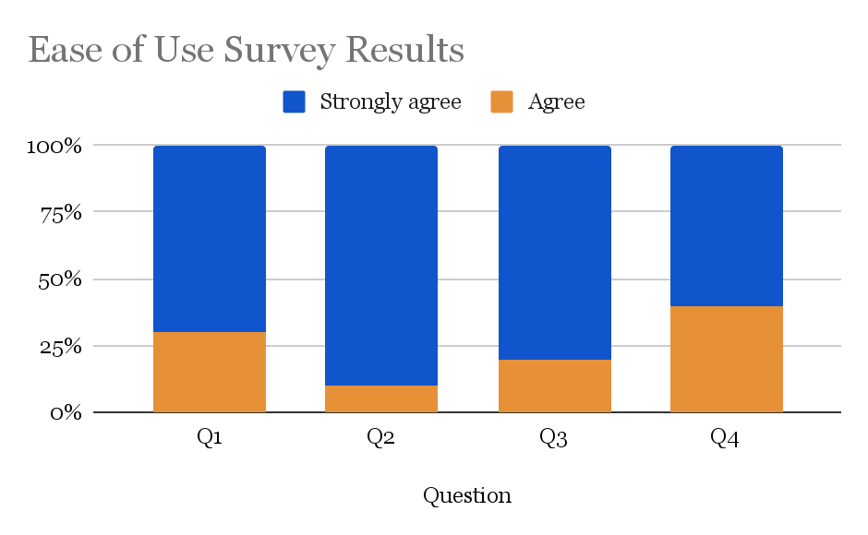

**Graph 1.** Survey results from ease of use survey form.

The four questions asked on the survey as shown in Table 9. to assess various aspects of the assembly and disassembly and use of our transfusion set. As shown by Graph 1. 100% of our participants rated our design a 4 or higher on a 5-point Likert scale. The average score was calculated for each question, with all questions receiving a score of 4.6 or higher. Therefore this passed our test criteria of 80% of our participants rating our design a 4 higher. We look forward to distributing this survey to nurses and doctors next to get more accurate responses in a healthcare context.

# Community Comfort

To gauge the comfort of the community with the idea of using a reusable blood-giving set we created a Qualtrics survey. This survey consisted of six questions surrounding how the community members felt about our design as a patient.

| **Question #** | **Question** | **Score** |
| --- | --- | --- |
| **Q1** | The appearance of reusable blood-giving set does not make me feel anxious or uncomfortable about its use. | 4.6 |
| **Q2** | I feel comfortable with the idea of using a blood-giving set that has been sterilized and reused for multiple patients. | 3.3 |
| **Q3** | I trust that the healthcare staff will ensure the reusable blood-giving set is safe and sterile for each patient. | 4.2 |
| **Q4** | I am open to using a reusable blood-giving set if it improves access to blood transfusion services in my community. | 4.2 |
| **Q5** | I trust that the healthcare staff will ensure the reusable blood-giving set is safe and sterile for family members in need of blood transfusion. | 4.1 |
| **Q6** | I trust that the healthcare staff will ensure the reusable blood giving set is safe and sterile for myself as a patient in need of blood transfusion. | 4.1 |

**Table 10.** Displays the questions asked on the survey

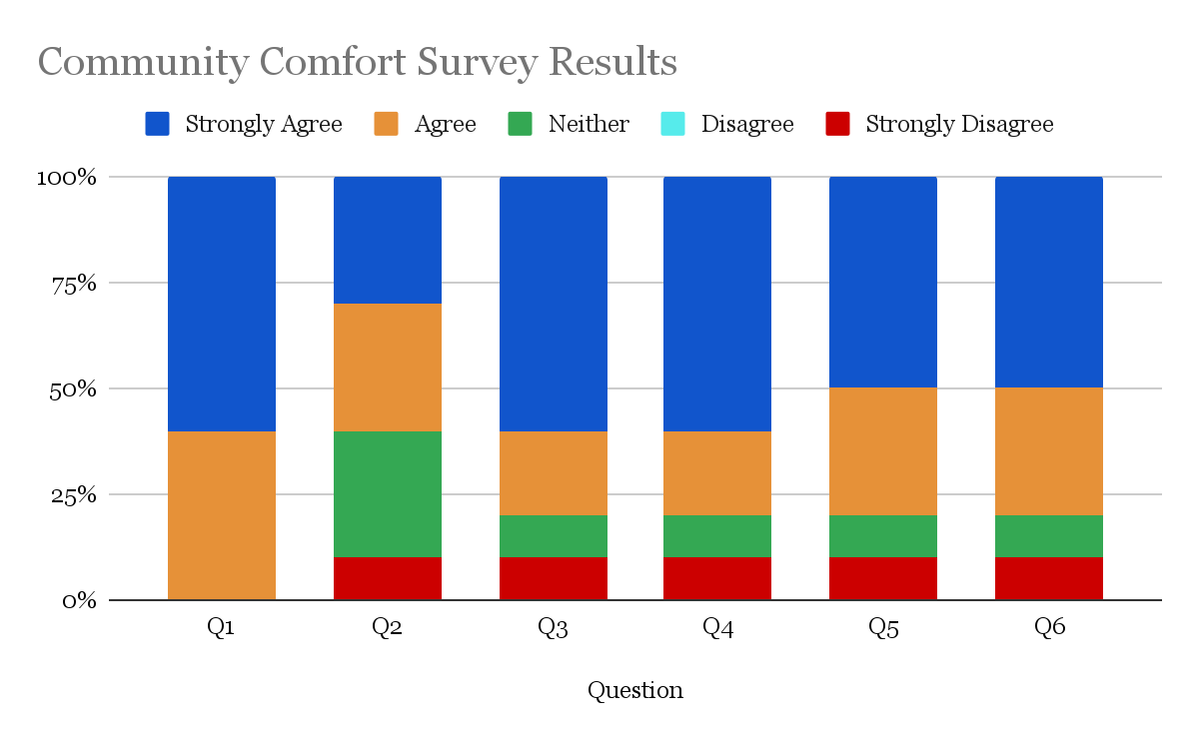

**Graph 2**. Survey results from community comfort survey form.

From the responses of our classmates, we found that most participants felt comfortable with our design and use of our device in a clinical setting. We visualized these responses as shown on Graph 2 above.The lowest-scoring question was about a patient's comfort with using a reusable set that has been sterilized. One way to address this hesitancy would be to create a detailed educational guide about our process and sterilization procedures with the implementation of our device.

Based on our results, we passed our testing criteria that 80% of patients rate our design as more comfortable or equally comfortable to a standard set, with an average score of 3 or higher. We plan to distribute this survey to patients of the new surgical center to gauge real community comfort once our device has been implemented. Additionally, since we did not expliciting benchmark our set compared to current blood-giving sets, we will explain that a score of 3 is equivalent to the comfortability of a standard set.

# Compact Sizing

This test was conducted to ensure that our reusable blood-giving set occupies no more space than a standard single-use set, addressing the limited storage space available in clinical and hospital settings. This validation test evaluates whether our set meets the spatial requirements for hospital use.

To perform this test, we compared the dimensions of our packaged set to those of a commercial single-use set. Both sets were measured while coiled and placed in their respective storage configurations—a ziplock bag for our set and a sterilized pouch for the commercial set. Using calipers, we recorded the length, width, and depth of each package and calculated their total volumes.

|  | **Length** | **Width** | **Depth** | **Total Volume** |
| --- | --- | --- | --- | --- |
| **Our set** | 6.6 in | 6.6 in | 0.9 in | 39.2 in3 |
| **Standard Set** | 10.0 in | 5.8 in | 1.0 in | 58.0 in3 |

**Table 11.** Dimensions and Volume Comparison of Blood-Giving Sets

The results indicate that our set is significantly more compact, with a total volume approximately 32% smaller than the standard single-use set. This confirms that our set meets the compact sizing criteria, making this test a success.

As we proceed with further prototyping and refine the design for enhanced durability and functionality, we will revisit this test to ensure the product remains as space-efficient as the predicate.

# Cost Efficient

This test was conducted to ensure that the total production cost of our reusable blood-giving set remains within the budgetary constraints of the clinic and the Malawian healthcare system. This validation test on affordability ensures that the device can be widely adopted and sustained in a resource-limited setting.

We performed a cost analysis based on our Bill of Materials (BOM). Material quotes were sourced to calculate the per-set production cost, ensuring it remains under the sponsor-provided limit of $100. The data collected is summarized in the table below.

| Component | Cost per unit | Cost Per Set | Comments |
| --- | --- | --- | --- |
| Platinum-Coated Silicone Tubing (I.D: 3mm) | $4.32/ft | $17.28 | Bought 25ft for $108. Each set uses 4 ft. |
| Platinum-Coated Silicone Tubing (I.D: 25.4 mm) | $1.93/ft | $0.32 | Bought 5ft got $9.65. Each set uses 2in. |
| BioMed Amber Resin | $249/L | $5.73 | Using Biomed Amber Resin. Use 23.03 mL per print. |
| Dowsil 734 Flowable Sealant | $36.00/3oz | $0.24 | $36 for 3oz. Found sum of total SA that is adhered and multiplied by the recommended max thickness of Dowsil (.75mm). Total: 576mm2 ~ .02oz |
| Stainless Steel Mesh (.18mm Hole) | $0.026/in2 | $0.14 | Bought 11.8 x 39.4in sheet for $11.97. Each set uses 5.57in2. |
| Total | – | $23.71 | – |

**Table 12.** Cost Breakdown of Reusable Blood-Giving Set

The total production cost for our set is $23.71, well below the $100 target, making this test a success. Notably, platinum-cured silicone tubing is the primary cost driver (73% of total cost). We have since identified a more competitive supplier, which will further reduce costs.

This cost analysis reflects only the per-set production cost. It excludes the initial cost of equipment (e.g., Formlabs printer), shipping costs, and labor. These factors will need to be considered in a full cost-of-ownership analysis as the project advances.  
  
Local Sourcing

We were unable to conduct the local sourcing test at this time, as we have not yet received a response from representatives at the Malawi University of Business and Applied Sciences. This test is critical for assessing the availability and feasibility of sourcing components and manufacturing equipment locally to ensure long-term sustainability and cost-effectiveness. Once we receive feedback and have a more in-depth discussion regarding the institution’s resources, we will be better equipped to evaluate the sourceability of our components and machines. This will allow us to accurately determine whether the design can be feasibly produced and maintained within the local context.

Testing Summary

| **Test** | **Design Objective** | **Testing Method** | **Results** |
| --- | --- | --- | --- |
| Bacterial Removal | Bacteria is able to be removed from our set after sterilization | Bacterial removal and sterilization testing | **PASS** |
| Blood Adhesion | Blood does not adhere to any of our components more than a surgical-grade metal | Blood adhesion and performance testing | **FAIL** |
| Biocompatibility | Ensure all materials used in the blood-giving set are biocompatible | Biocompatibility and BOM | **FAIL** |
| Compressive Strength | Our set is durable enough to withstand rough handling, transport, and compressive forces | Compressive strength testing | **PASS** |
| Drop Test | Our set is capable of withstanding standard drop heights and maintaining its functionality afterward | Drop testing | **FAIL** |
| Flow Modulation | Our set provides consistent and adjustable flow rates | Flow modulation testing | **FAIL** |
| Leakage | Our device must maintain an air-tight seal with no leakage | Leakage test | **PASS** |
| Filtration | Our filter is capable of separating blood clots and large debris | Filtration testing | **PASS** |
| Ease of Use | Our device should be easy to use | User survey | **PASS** |
| Community Comfort | Our device is comfortable and not threatening to the community members | User Survey | **PASS** |
| Compact Sizing | Our device is similar in size to standard blood-giving sets | Self-evident by dimensions | **PASS** |
| Cost Efficient | Our device is cost-efficient | Self-evident by BOM | **PASS** |

**Table 13.** Summary of our testing results

**6.3 Prototype update**

This document provides an update on the latest iteration of our prototype, starting from the version introduced in WA#5. Each modification is described, justified, and informed by feedback received from our community partners.

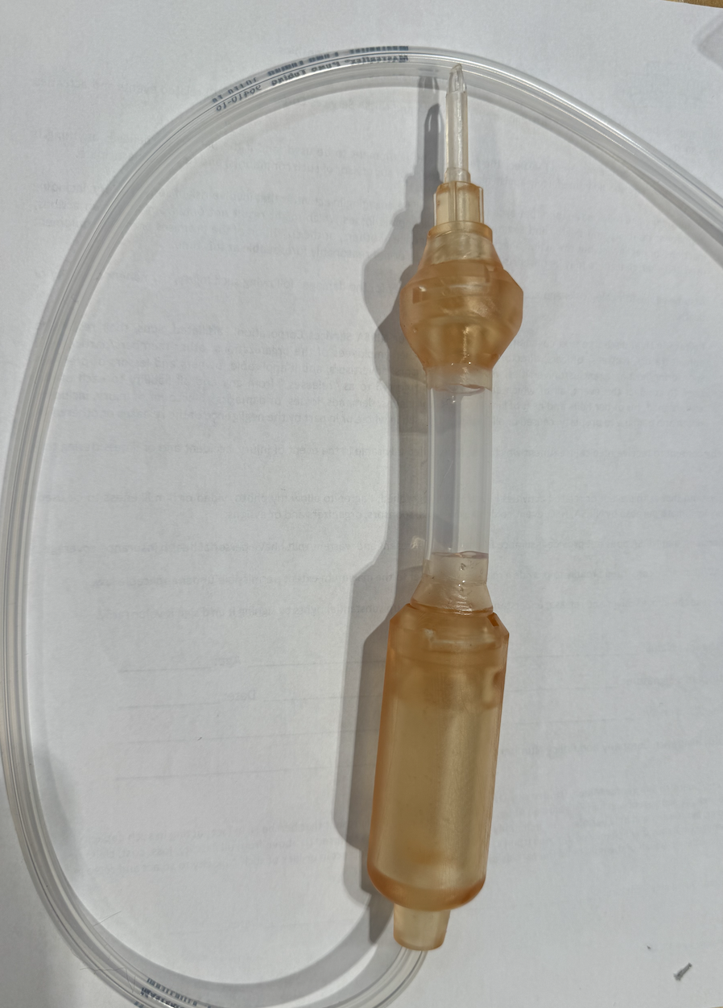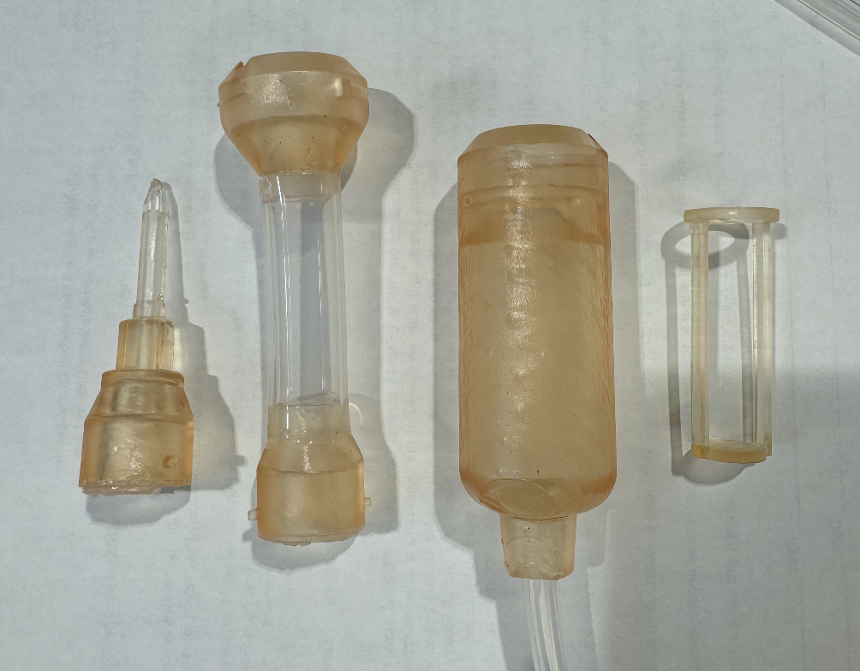

**Figure 1 (left).** Fully assembled latest prototype

**Figure 2 (right).** Prototype components (excluding the flow modulator) from left to right: spike, flexible drip chamber component, hard drip chamber component, and filter

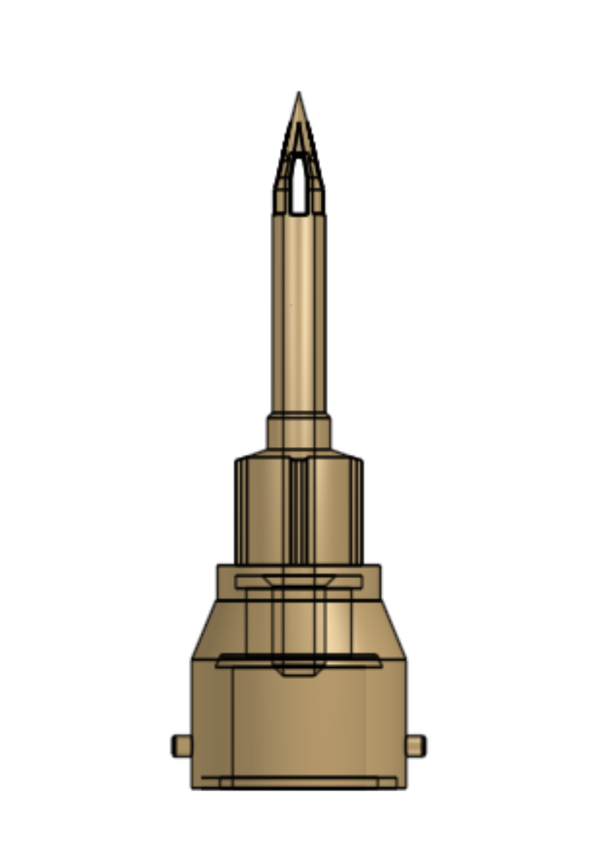 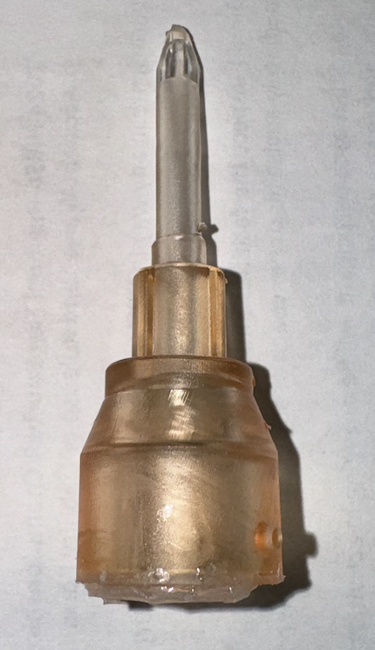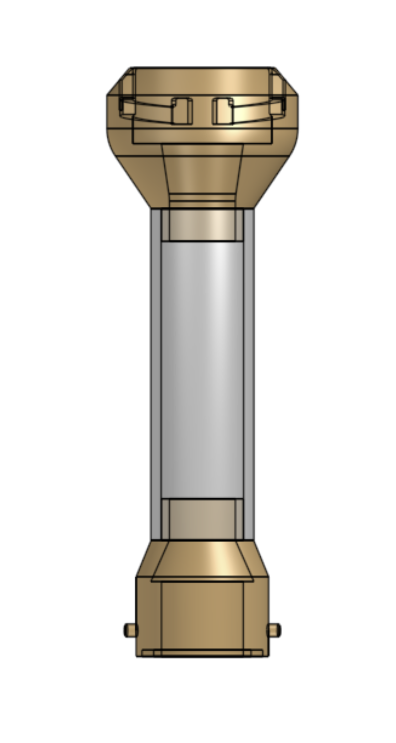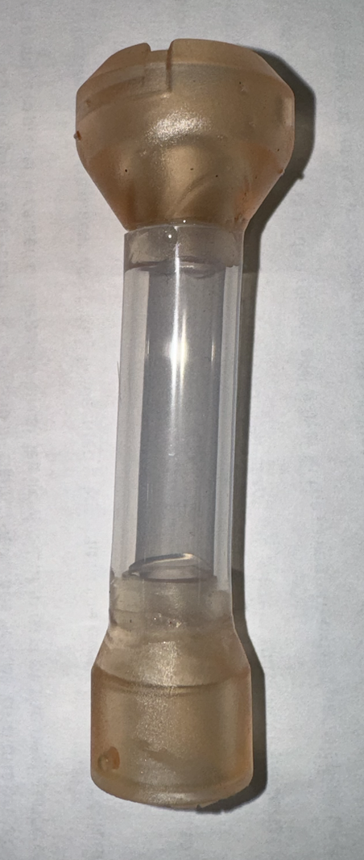

**Figure 3 (left).** Displays both the 3D printed file and the resultant printed component of the spike.

**Figure 4 (right).** Illustrates the 3D printed file and the assembly of the printed components of the drip chamber's top component. The top of the drip chamber is made of large silicone-cured tubing and permanently adhered to 3D printed connectors

The most significant change in this iteration is the transition from screw-in components to a twist-and-lock mechanism. This decision was driven by three key challenges with the screw-in design. First, achieving precise tolerances for the screw threads proved difficult, resulting in inconsistencies during assembly. Second, there were concerns about long-term wear, as repeated use could degrade the threads, potentially leading to component failure. Finally, maintaining a reliable airtight seal with screw connections was challenging, which could compromise the sterility and functionality of the system.We expressed these concerns with our community partners on 11/3 and asked what they thought of transitioning to a twist-and lock mechanism. They thought that it made sense and also might make the device easier to use. They were curious what this would look like and want us to show them once we refine it a bit.

The new twist-and-lock design addresses these issues comprehensively. It features a male component with two extruded circular knobs that fit into channels on the female counterpart. These knobs travel along the channels, allowing the components to twist and securely lock into place. To ensure an airtight seal, a platinum-cured O-ring is incorporated into the design. This O-ring is compressed during the locking process, creating a robust seal that prevents air leakage and maintains sterility. Additionally, the twist-and-lock mechanism simplifies the assembly process, reducing the likelihood of user error and ensuring consistent performance even after repeated use.

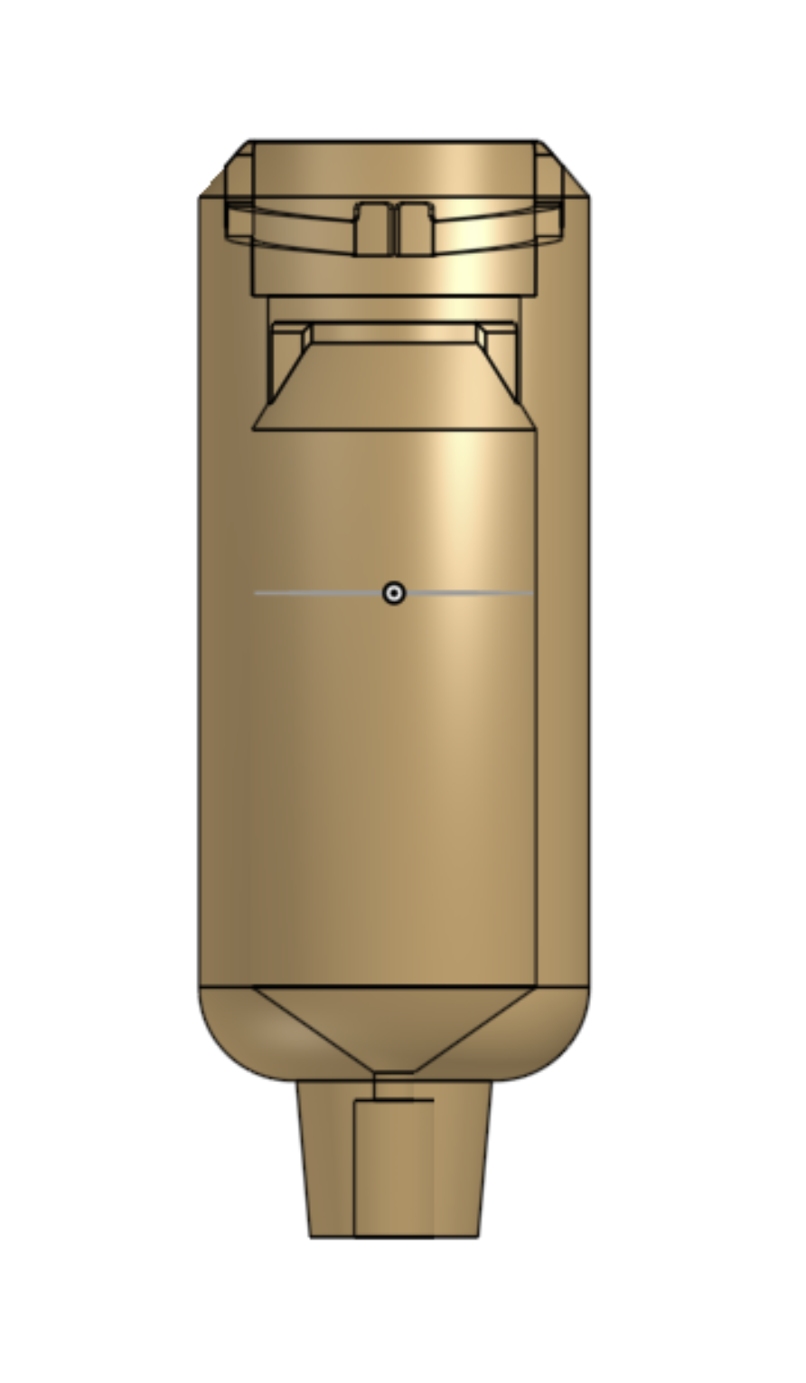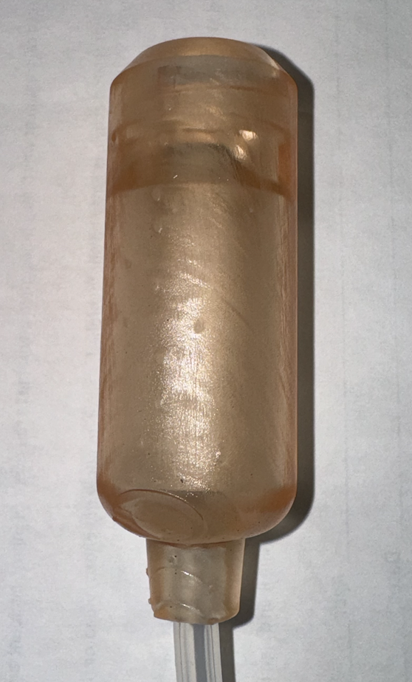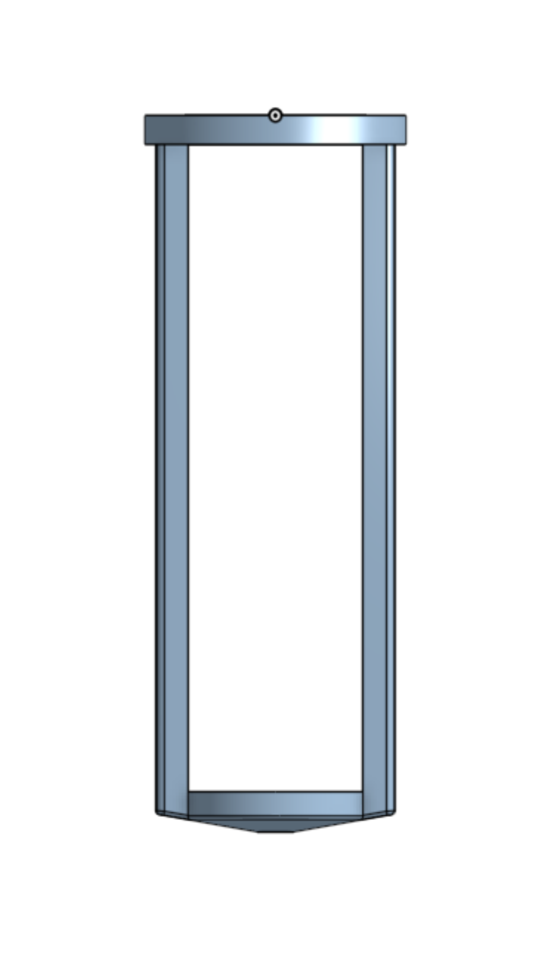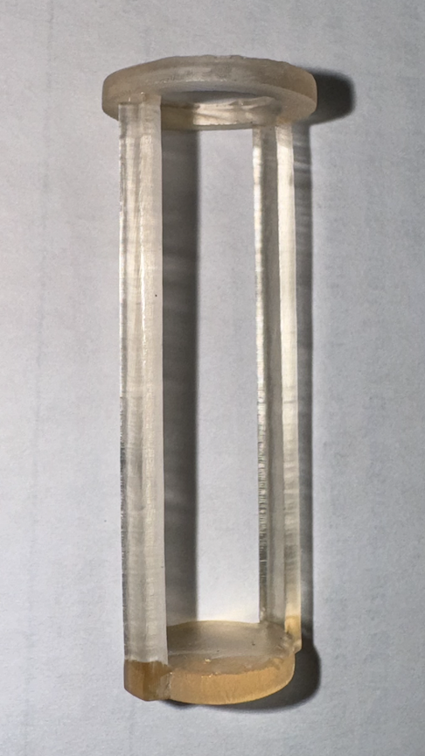

**Figure 5 (left).** Displays both the 3D printed file and the resultant printed component of the 3D printed part of the drip chamber.

**Figure 6 (right).** Illustrates the 3D printed file and the resultant print of the filters skeleton

In this version, the drip chamber was significantly redesigned to be larger and deeper. This modification addresses the fragility of the previous filter, which broke during testing. The increased chamber size now supports a filter with a surface area comparable to industry-standard filters, improving both functionality and reliability.

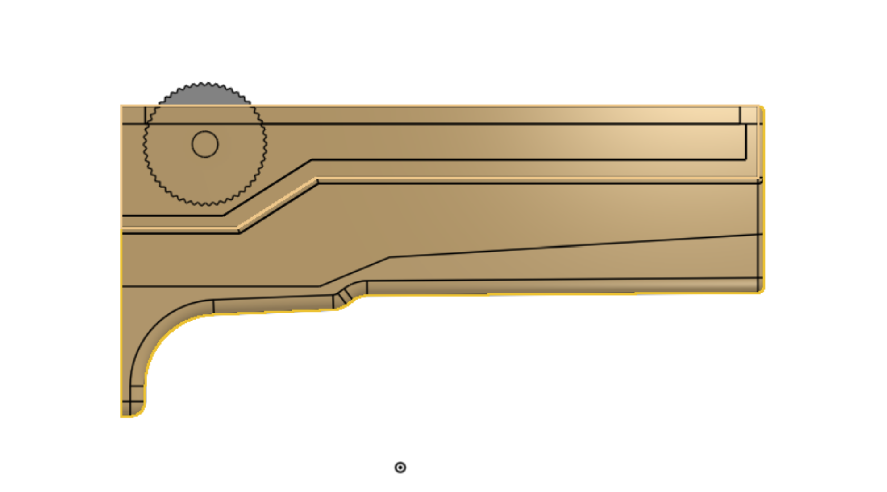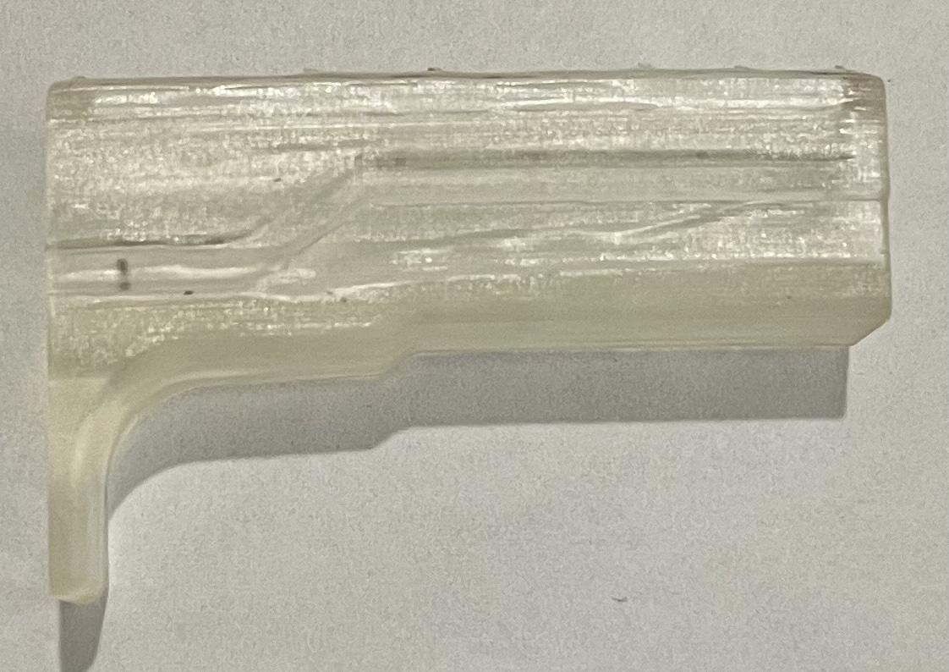

**Figure 7 (right).** 3D printed file and resultant printed component of the updated flow regulator

Our previous flow modulator faced several issues, including difficulties with gradual modulation and structural weaknesses. The thin sidewalls often cracked and broke, compromising the device's durability. Additionally, the roller lacked ridges, making it harder to achieve smooth, controlled adjustments.

In the updated prototype, we addressed these issues by redesigning the modulator with a more gradual angle, enabling slower and more precise flow modulation. The modulator walls have been thickened to enhance robustness, and ridges were added to the roller to improve usability. Moving forward, we plan to incorporate a dovetail slot on one side of the modulator. This feature will allow the modulator to slide on and off the tubing easily, facilitating removal for sterilization without compromising the design's integrity or ease of use.

WA7

Written Assignment 7: Training, handoff, continuation plan for partners

**Objective:**

The objective of this assignment is for each team to effectively transfer their solution to their community partner or future design teams.

**Description:**

This assignment should include the upload of two separate components. 1) The hand-off documentation and 2) Justification document.

Part 1:

**Hand-off documents**.

This report should serve as a stand-alone piece of work that can be directly provided to your community partner in addition to the physical prototype. This includes training documentation, hand-off methodology, an organized and clear design file repository with a readme file to describe contents, and a continuation plan for partners or future design teams. This document will look different for every team; however, each team will be graded based on the completeness of this report with respect to their individual project.

**Summary** - Darcy

The past semester we have spent working on our reusable blood-giving set can be broken down into four main categories: initiation, planning and design, execution, and finalization. In the initiation stage, we created our team charter to set expectations for the semester as a team. Then we interviewed our clients involved with the Pothawira Surgical Center in Salima, Malawi. This interview with Dr. Anne and Dr. Joanie, help direct our project, providing background to Malawi and the surgical center and insights into the blood-giving process currently implemented.

The next stage in our engineering design was the planning and design of our project. First, we began by researching the community context and potential materials for our project. This initial research informed our needs statement and design criteria. Our needs statement is as follows:

*“The Pothawira Surgical Center in Salima, Malawi needs a method for affordable, reusable, and sterilizable blood-giving sets and a blood-warming device that can safely warm stored blood to the optimal transfusion temperature.”*

Then we shifted to focus on brainstorming. We implemented two brainstorming methods, keeping in mind our design criteria for the set. We narrowed down our brainstormed ideas for each component through trade studies. Some of our design components did not require a trade study including our tubing and needle connection. The tubing must be sterilizable and can be sourced, and the needle connection must be a standard luer lock connection to maintain compatibility. We were also able to source our adhesive

Some important design choices we chose based on the trade studied include a two-chamber drip chamber, the roller clamp for our flow modulation.

After a few rounds of brainstorming and trade studies, we sketched our initial design solution. In addition to our initial sketch, we also researched prior art and conducted a literature review. Our research, literature review, and trade studies ensured our design solution was well-informed. Once all of our background and initial research had been completed we began designing and building our initial prototype.

**Plan for Next Semester** - Hannah

Our future work next semester will focus on refining the reusable blood transfusion set, ensuring it aligns with global medical standards, and improving its functionality to meet the needs of our community partner. The following outlines our detailed objectives and tasks:

Gitlab repository - Jason

Part 2:

**Justification - Michaela**

This document should defend your decision on what to include and what not to include in your hand-off document. This document will be used to assess the completeness of hand-off documents. All parts of your project that you include as “important” for your partner in this justification must be included with sufficient detail in your hand-off document.

What is your responsibility and role in the hand-off of these materials, and how will you make this project more sustainable through this handoff? How have you considered your partner's needs in the design process through global, economic, environmental, and societal contexts? (You must include thoughts on each context to receive full points).

This document should also include your plan for how you will contact/provide your prototype to your partner.

Given that our hand-off document will be iterated on in the future, we decided to focus more on the plan for next semester. Our current hand-off documentation primarily consists of the github repository for the component parts. We will give our community partner access to the repository to see the design files that are currently being used. This is the most effective way to communicate our design to our partner since it would be extremely costly and inefficient to send them each of the components we have iterated on. By providing them with the dimensions we currently have for our components, they can evaluate whether or not our prototypes will fit their components and needs.

We have been in communication with our partner consistently through whatsapp and have had several zoom calls to give updates and get guidance on our current prototypes. We aim to continue this line of communication and build a stronger one with our contact at the university. Given the infrastructure in Malawi

Appendix

# Appendix

## Written Assignment 1: Description, Skills, Objectives

**Goals and Objectives**

*Team Goals*

* A minimum of 2 members get certified and access to the Pratt Student Shop
* Maintain continuous communication through the engineering design process with our client
* Develop and introduce a product that meets the design criteria set throughout the semester

*Individual Goals*

Darcy: Gain a better understanding of blood safety standards, sterility protocols, and regulatory requirements for blood transfusion sets.

Hannah: Contribute to Pothawira’s new OR through a working device while also learning how to ethically tackle engineering design problems in low-income settings.

Jason: Understand and address the current issues of Potherwira while continuing to develop and build upon my engineering skills. Learn global health and the engineering process from our client and my teammates.

Michaela: I want to develop my teamwork and project management skills. I think these skills are very translatable to every aspect of life and this is a great opportunity to work on them.

**Milestones and Timeline**

Link to our Gantt Chart

[Project Management Gantt Chart Template](https://docs.google.com/spreadsheets/d/17mtXtkyZlYur7MHHV455RunMY4lefjXYqgFI0Hixe1c/edit?usp=sharing)

**Roles**

* At the beginning of each week, we will have a team meeting to discuss roles and goals for the week
* We will remain in communication when we complete a task or are struggling and need support from team members
* Tasks will be documented on an organizational website to track progress
* Michaela: Arduino/coding, circuitry
* Darcy: Organization, CAD, and prototyping
* Hannah: CAD, circuitry/soldering, Maintaining communication w/client
* Jason: Presenting, CAD, Firmware Coding

**Processes**

When and where will the team meet?

* Weekly meetings as a group on Wednesday mornings at 10 am in Gross Hall
* Utilize when2meet
* Attendance is expected for every meeting as a whole team, except when sick or prior communication to missing a meeting

How will the team communicate?

* Text group chat
* Teams

Where will the team save files, manage data, etc.?

* Share google drive
* Git (Coding Documents/CAD Files)

How will decisions be made?

* Group consensus

How will the team track its progress?

* Use of Gantt chart

**Team Norms**

* Active participation
* Clear communication
  + Notifying the team once you have completed a task
* Taking ownership
* Notification of absences communicated before meetings
* Aiming to complete tasks early/avoid last-minute changes

**Signature of Team Members**

Darcy Ayers

Michaela Harris

Hannah Kragt



**Meeting Notes**

[**Meeting Minutes**](https://docs.google.com/document/d/1oR-cMhyp5ghlP9S-Zq99qJtlZuWzAPr7VUT-FfFZucY/edit?usp=sharing)

**Interview Notes**

[**9/11 Interview Notes**](https://docs.google.com/document/d/1gfVj_sT0WZNHvcMYFkR1uiB6jIyV4EIgsOkbemMGZ28/edit?usp=sharing)

[**Nurse Interview Questions**](https://docs.google.com/document/d/1tIve8V-Hy6ToohbioruxA8sO6YG159Bs_v-f1x9MQW8/edit?usp=sharing)

[**11/3 Interview Notes**](https://docs.google.com/document/d/1SwyffeUhmM3eqPtCdnfWb5ij4SCP_1geZzSJN0bjblI/edit?usp=sharing)

**Calculations**

**Flow Modulation Testing**

Max flow = 476.1 mL → 0.476 L

$\frac{0.476 L}{60 s}= 0.0079 L/s$

**100% modulation**

**Trial 1**

473.2 mL → 0.4732 L

$\frac{0.473 L}{60 s}= 0.0079 L/s$

% of max flow = $\frac{0.0079}{0.0079}x100 = 100\%$

**Trial 2**

443.6 mL → 0.4436 L

$\frac{0.4436 L}{60 s}= 0.0074 L/s$

% of max flow = $\frac{0.0074}{0.0079}x100 = 93.7\%$

**Trial 3**

467.3 mL → 0.4673 L

$\frac{0.467 L}{60 s}= 0.0078 L/s$

% of max flow = $\frac{0.0078}{0.0079}x100 = 98.7\%$

**75% modulation**

**Trial 1**

360 mL → 0.360 L

$\frac{0.36 L}{60 s}= 0.006 L/s$

% of max flow = $\frac{0.006}{0.0079}x100 = 76\%$

**Trial 2**

390 mL → 0.39 L

$\frac{0.39 L}{60 s}= 0.0065 L/s$

% of max flow = $\frac{0.0065}{0.0079}x100 = 82.3\%$

**Trial 3**

500 mL → 0.5 L

$\frac{0.5 L}{60 s}= 0.0083 L/s$

% of max flow = $\frac{0.0083}{0.0079}x100 = 105.5\%$

**50% modulation**

**Trial 1**

490 mL → 0.49 L

$\frac{0.49 L}{60 s}= 0.0081 L/s$

% of max flow = $\frac{0.0081}{0.0079}x100 = 103.4\%$

**Trial 2**

470 mL → 0.47 L

$\frac{0.47 L}{60 s}= 0.0078 L/s$

% of max flow = $\frac{0.0078}{0.0079}x100 = 99.2\%$

**Trial 3**

500 mL → 0.5 L

$\frac{0.5 L}{60 s}= 0.0083 L/s$

% of max flow = $\frac{0.0083}{0.0079}x100 = 105.5\%$

**25% Modulation**

**Trial 1**

225 mL → 0.225 L

$\frac{0.225 L}{60 s}= 0.038 L/s$

% of max flow = $\frac{0.0038}{0.0079}x100 = 47.5\%$

**Trial 2**

400 mL → 0.4 L

$\frac{0.4 L}{60 s}= 0.0067 L/s$

% of max flow = $\frac{0.0067}{0.0079}x100 = 84.3\%$

**Trial 3**

400 mL → 0.4 L

$\frac{0.4 L}{60 s}= 0.0067 L/s$

% of max flow = $\frac{0.0067}{0.0079}x100 = 84.3\%$

Resources

# Resources

[1] G. A. Abiiro, G. B. Mbera, and M. De Allegri, "Gaps in universal health coverage in Malawi: A qualitative study in rural communities," *BMC Health Serv. Res.*, vol. 14, p. 234, 2014. [Online]. Available:<https://doi.org/10.1186/1472-6963-14-234>

[2] Malawi Project, "Inside the Salima District Hospital—A Tier Two Facility," *Malawi Project*, Aug. 24, 2007. [Online]. Available:<https://www.malawiproject.org/inside-the-salima-district-hospital-a-tier-two-facility/>

[3] "Salima District in Malawi｜Malawi Travel and Business Guide," *Malawi Plus*. [Online]. Available:<https://malawiplus.com/salima/>. [Accessed: Sept. 12, 2024].

[4] E. Kalipeni, "Health and disease in Southern Africa," 2000.

[5] W. Chilowa, "The impact of agricultural liberalisation on food security in Malawi," 1998.

[6] A. S. Muula and J. M. Mfutso-Bengo, "Responsibilities and obligations of using human research specimens," 2005.

[7] Global Fund, "Malawi: Strengthening the national health system," 2022.

[8] World Health Organization. (2016). *Malawi Country Cooperation Strategy*. WHO Regional Office for Africa.

[9] Ministry of Health, Malawi. (2020). *National Health Strategic Plan 2021-2026*. Lilongwe: Ministry of Health.

[10] Government of Malawi. (2021). *Decentralization Policy and Local Governance Structure*.

[11] Global Fund. (2019). *Malawi Health System Overview*.

[12] "Malawi," *Datadot*. [Online]. Available:<https://data.who.int/countries/454>. [Accessed: Sept. 12, 2024].

[13] "Malawi Priorities: Utilities," *Copenhagen Consensus*. [Online]. Available:<https://copenhagenconsensus.com/publication/malawi-priorities-utilities>. [Accessed: Sept. 12, 2024].

[14] "Salima District in Malawi｜Malawi Travel and Business Guide," *Malawi Plus*. [Online]. Available:<https://malawiplus.com/salima/>. [Accessed: Sept. 12, 2024].

[15] "Vatican visit by Malawi’s president reflects church’s role amid food crisis, upcoming elections," *National Catholic Reporter*. [Online]. Available:<https://www.ncronline.org/news/vatican-visit-malawis-president-reflects-churchs-role-amid-food-crisis-upcoming-elections>. [Accessed: Sept. 12, 2024].

[16] "We Are Starving: Malawi Villagers Cook Toxic Yams To Survive Drought," *Barron’s*. [Online]. Available:<https://www.barrons.com/news/we-are-starving-malawi-villagers-cook-toxic-yams-to-survive-drought-0eeb8686>. [Accessed: Sept. 12, 2024].

[17] E. Pire, "State of Knowledge: Energy Access in Malawi," *EPPSA*, 2023. [Online]. Available:<https://doi.org/10.17615/wy2b-hk49>

[18] "Malawi: Japan Invests High Power Solar System for Salima District Hospital," *AllAfrica*, 2023. [Online]. Available:<https://allafrica.com/stories/202303060132.html>

[19] "Global health: Malawi," *U.S. Agency for International Development*, Feb. 14, 2023. [Online]. Available:<https://www.usaid.gov/malawi/global-health#:~:text=Even%20with%20the%20gains%20in,episodes%20of%20malaria%20per%20year>. [Accessed: Sept. 12, 2024].

[20] K. van den Berg et al., “A review of the use of blood and blood products in HIV-infected patients,” Southern African journal of HIV medicine, vol. 13, no. 2, p. 87, Jun. 2012, doi: 10.4102/sajhivmed.v13i2.146.

[21] “Treatments.” Accessed: Nov. 11, 2024. [Online]. Available: <https://stanfordhealthcare.org/medical-conditions/primary-care/malaria/treatments.html>

[22] "Blood Safety and Availability," *World Health Organization*, 2021. [Online]. Available: <https://www.who.int/news-room/fact-sheets/detail/blood-safety-and-availability>"Blood Safety and

[23] "Global Blood Supply Challenges," *Transfusion News*, Sep. 11, 2024. [Online]. Available: <https://transfusionnews.com/2024/09/11/global-blood-supply-challenges/>

[24] L. S. Barnes et al., "Status of hospital-based blood transfusion services in low-income and middle-income countries: a cross-sectional international survey," *BMJ Open*, vol. 12, no. 2, p. e055017, 2022. [Online]. Available: <https://bmjopen.bmj.com/content/12/2/e055017>

[25] S. E. Njolomole et al., "Meeting demand—Obstetric hemorrhage and blood availability in Malawi, a qualitative study," *PLoS ONE*, vol. 17, no. 8, p. e0273426, Aug. 2022. [Online]. Available: https://doi.org/10.1371/journal.pone.0273426

[26] "Malawi Blood Transfusion Service," *MBTS Malawi*, 2023. [Online]. Available: [https://mbtsmalawi.com](https://mbtsmalawi.com/). [Accessed: 25-Sep-2024]

[27] "The Development of Modern Blood Transfusions," *Encyclopedia.com*, 2024. [Online]. Available: <https://www.encyclopedia.com/science/encyclopedias-almanacs-transcripts-and-maps/development-modern-blood-transfusions>. [Accessed: 25-Sep-2024].

[28] "Advancements in Transfusion Medicine," *College of American Pathologists*, 2024. [Online]. Available: [https://www.cap.org](https://www.cap.org/). [Accessed: 25-Sep-2024].

[29] "Blood Transfusion Sets: A Complete Handbook on Components, Types, and Best Practices," Medzell, 2024.

[30] "ISO 1135-4:2015 Transfusion Equipment for Medical Use - Part 4: Transfusion Sets for Single Use, Gravity Feed," International Organization for Standardization, 2015.

[31] Y. Yang, X. Zhang, J. Li, Y. Liu, “Disposable Blood Transfusion Device for Conveniently Cleaning Pipeline,” CN202942487U, 2013.

[32] LifeWarmer, "Quantum Thermal Transfusion Set - Blood," LifeWarmer, 2024.

[33] T. Ackfeld, T. Schmutz, Y. Guechi, and C. Le Terrier, "Blood Transfusion Reactions—A Comprehensive Review of the Literature including a Swiss Perspective," *J Clin Med.*, vol. 11, no. 10, p. 2859, 2022.

[34] L. Zimmerman and K. Howell, “History of Blood Transfusion,” in Annals of Medical History, vol. IV, 1932, p. 19. [Online]. Available: https://www.ncbi.nlm.nih.gov/pmc/articles/PMC7945273/pdf/annmedhist148147-0003.pdf

[35] J. H. Stokes and G. J. Busman, “TUBING AS A CAUSE OF REACTION TO INTRAVENOUS INJECTION, ESPECIALLY OF ARSPHENAMIN: PRELIMINARY REPORT,” JAMA, vol. 74, no. 15, p. 1013, Apr. 1920, doi: 10.1001/jama.1920.02620150021008.

[36] I. M. Libkach, “Blood Program in World War II: Office of the Surgeon‐General Department of the Army: Washington D.C. U.S.A.1964. Pp. 922. Price $8.00.,” Int J Clinical Practice, vol. 20, no. 1, pp. 57–57, Jan. 1966, doi: 10.1111/j.1742-1241.1966.tb06957.x.

[37] J. Curtis and A. Colas, “Chapter II.5.18 - Medical Applications of Silicones,” in Biomaterials Science (Third Edition), B. D. Ratner, A. S. Hoffman, F. J. Schoen, and J. E. Lemons, Eds., Academic Press, 2013, pp. 1106–1116. doi: 10.1016/B978-0-08-087780-8.00107-8.

[38] JohnF. Wilkinson, G. G. Freeman, N. New, and R. B. Noad, “SILICONE-RUBBER TUBING IN BLOOD-TRANSFUSION WORK: CLINICAL TRIALS,” The Lancet, vol. 268, no. 6943, pp. 621–624, Sep. 1956, doi: 10.1016/S0140-6736(56)92310-8.

[39] S. Baccheschi, L. Sereni, C. D. Nitti, R. Barbucci, and C. Tetta, “BLOOD TUBING AND CYTOKINE PRODUCTION: EFFECT OF STERILIZATION,” Renal Failure, vol. 23, no. 3–4, pp. 411–418, Jan. 2001, doi: 10.1081/JDI-100104724.

[40] M.-F. Harmand and F. Briquet, “In vitro comparative evaluation under static conditions of the hemocompatibility of four types of tubing for cardiopulmonary bypass,” Biomaterials, vol. 20, no. 17, pp. 1561–1571, Sep. 1999, doi: 10.1016/S0142-9612(99)00051-4.

[41] E. J. Brisbois, T. C. Major, M. Goudie, R. H. Bartlett, M. E. Meyerhoff, and H. Handa, “Improved Hemocompatibility of Silicone Rubber Extracorporeal Tubing via Solvent Swelling-Impregnation of S-Nitroso-N-acetylpenicillamine (SNAP) and Evaluation in Rabbit Thrombogenicity Model,” Acta Biomater, vol. 37, pp. 111–119, Jun. 2016, doi: 10.1016/j.actbio.2016.04.025.

[42] “Biocompatibility Testing of Medical Devices: Guidance for Industry, Accreditation Bodies, Testing Laboratories, and Food and Drug Administration Staff ,” Food and Drug Administration, Sep. 2024. [Online]. Available: <https://www.fda.gov/media/182026/download>

[43] “Coronary, Peripheral, and Neurovascular Guidewires – Performance Tests and Recommended Labeling: Guidance for Industry and Food and Drug Administration Staff,” Food and Drug Administration, Oct. 2019. [Online]. Available: <https://www.fda.gov/media/113959/download>

[44] “CFR - Code of Federal Regulations Title 21,” FOOD AND DRUG ADMINISTRATION, Aug. 2024. [Online]. Available: <https://www.accessdata.fda.gov/scripts/cdrh/cfdocs/cfcfr/cfrsearch.cfm?fr=800.20>

[45] “Hemodialysis Blood Tubing Sets: Guidance for Industry and FDA Staff ,” Food and Drug Administration , Apr. 2008. [Online]. Available: <https://www.fda.gov/files/medical%20devices/published/Hemodialysis-Blood-Tubing-Sets---Premarket-Notification-%5B510%28k%29%5D-Submissions---Guidance-for-Industry-and-FDA-Staff.pdf>

[46] “Use of International Standard ISO 10993-1, ‘Biological evaluation of medical devices - Part 1: Evaluation and testing within a risk management process’: Guidance for Industry and Food and Drug Administration Staff,” Food and Drug Administration, Sep. 2023. [Online]. Available: <https://www.fda.gov/media/142959/download>

[47] S. Cito, M. D. Mazzeo, and L. Badimon, “A Review of Macroscopic Thrombus Modeling Methods,” Thrombosis Research, vol. 131, no. 2, pp. 116–124, Feb. 2013, doi: 10.1016/j.thromres.2012.11.020.

[48] S. Kattula et al., “Factor XIII in plasma, but not in platelets, mediates red blood cell retention in clots and venous thrombus size in mice,” Blood Advances, vol. 2, no. 1, pp. 25–35, Jan. 2018, doi: 10.1182/bloodadvances.2017011890.

[49] “Patient-Focused Drug Development: Methods to Identify What Is Important to Patients,” Food and Drug Administration, Feb. 2022. [Online]. Available: <https://www.fda.gov/media/131230/download>

[50] P. A. Bishop and R. L. Herron, “Use and Misuse of the Likert Item Responses and Other Ordinal Measures,” International Journal of Exercise Science, vol. 8, no. 3, p. 297, Jul. 2015, [Online]. Available: <https://pmc.ncbi.nlm.nih.gov/articles/PMC4833473/>

[51] “What Is Autoclave Sterilization? | Technical Safety Services.” Accessed: Nov. 11, 2024. [Online]. Available: <https://techsafety.com/blog/autoclave-sterilization#:~:text=What%20makes%20up%20a%20sterilization,and%20cooling%20down%20the%20chamber>

[52] “Platinum Cured Silicone: How It Expands the Use of Silicone Rubbers,” HM Royal. Accessed: Nov. 11, 2024. [Online]. Available: <https://hmroyal.com/blog/platinum-cured-silicone-how-platinum-curing-expands-the-use-of-silicone-rubbers/>

[53] “Buddy Lite - Portable IV & Infusion Pump | Belmont Medical.” Accessed: Nov. 11, 2024. [Online]. Available:<https://belmontmedtech.com/portable-iv-pump>

[56] Avantor Fluid Handling, *Certificate of Quality for Tubing MFLEX Silicone No. 16 25FT*, Dec. 2027. [Online]. Available: <https://us.vwr.com/assetsvc/asset/en_US/id/39649788/contents/39649788.pdf>

[57] Formlabs, *BioMed Amber Resin Technical Data Sheet*, Rev. 02, Jan. 2023. [Online]. Available: <https://formlabs-media.formlabs.com/datasheets/2001403-TDS-ENUS-0.pdf>

[58] Dow Chemical Company, *DOWSIL™ 734 Flowable Sealant Technical Data Sheet*, Form No. 95-1058-01-0220, 2020. [Online]. Available: <https://www.dow.com/en-us/document-viewer.html?docPath=/content/dam/dcc/documents/95/95-1/95-1058-01-dowsil-734-flowable-sealant.pdf>

[59] Y. Xu, Y. Li, T. Chen, C. Dong, K. Zhang, and X. Bao, “A short review of medical-grade stainless steel: Corrosion resistance and novel techniques,” *Journal of Materials Research and Technology*, vol. 16, pp. 2400–2415, 2024. [Online]. Available: <https://doi.org/10.1016/j.jmrt.2024.01.240>

[60] Cold & Colder, “Ultra Clear Pure Silicone Tubing,” [Online]. Available: <https://coldandcolder.com/collections/featured-products/products/silicone?variant=41786948157613>.

[61] StarFish Medical, “Medical device drop test,” *StarFish Medical Blog*, Nov. 30, 2022. [Online]. Available:<https://starfishmedical.com/blog/medical-device-drop-test/>

[62] Sigma-Aldrich, "Microbial growth," [Online]. Available:<https://www.sigmaaldrich.com/US/en/technical-documents/protocol/cell-culture-and-cell-culture-analysis/microbial-cell-culture/microbial-growth>.

[63] NCBI, "Microbial cell culture," [Online]. Available:<https://pmc.ncbi.nlm.nih.gov/articles/PMC6375084/#:~:text=Inoculate%20the%20liquid%20with%20a,liquid%20and%20shaking%20it%20a>.

[64] Centers for Disease Control and Prevention, "Steam sterilization," [Online]. Available:<https://www.cdc.gov/infection-control/hcp/disinfection-sterilization/steam-sterilization.html#:~:text=Recognized%20minimum%20exposure%20periods%20for,prevacuum%20sterilizer%20(Table%207)>.

[65] VATA Inc., "Simulated blood: Same viscosity as real blood," [Online]. Available:<https://vatainc.com/product/simulated-blood-same-viscosity-as-real-blood-stain-resistant-one-quart/>.

[66] Thermo Fisher Scientific, "Overview of endotoxin testing methods," [Online]. Available:<https://www.thermofisher.com/us/en/home/life-science/protein-biology/protein-purification-isolation/protein-purification/endotoxin-quantitation-removal/overview-of-endotoxin-testing-methods.html#:~:text=The%20use%20of%20the%20amebocyte,life%20science%20and%20medical%20research>.